🡪Update local cache

Python-devel: Libraries and source.. In future if we want to build any plugin

Pip: Plugin manager or Module manager for python...

**These dependencies are required for some of modules, because Ansibe run playbooks that are written in Python**

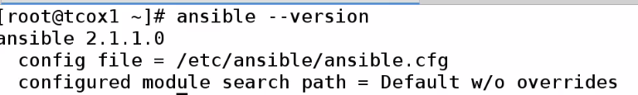

**Change Config:**



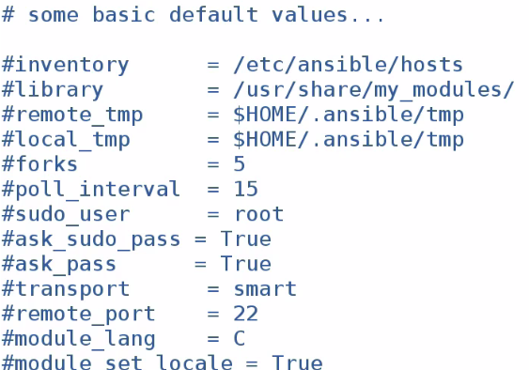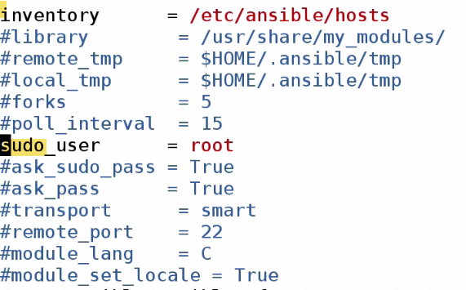

**Inventory: We can specify other inventory locations. In this case, we are going to have global Inventory hosts file.**

**When we run commands as sudo, then it will run as root user.**

**There are also ssh values, module, bash values in this file.**

**As there is no daemon running in Ansible, not required to restart. Ansible will read config file.., every time we run Ansible cmds.**

**When we run Ansible cmds or playbooks, we run against Nodes (identified by name). Names are like DNS entry, indicated by values in hosts file.**

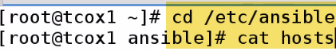****

**We created 3 groups**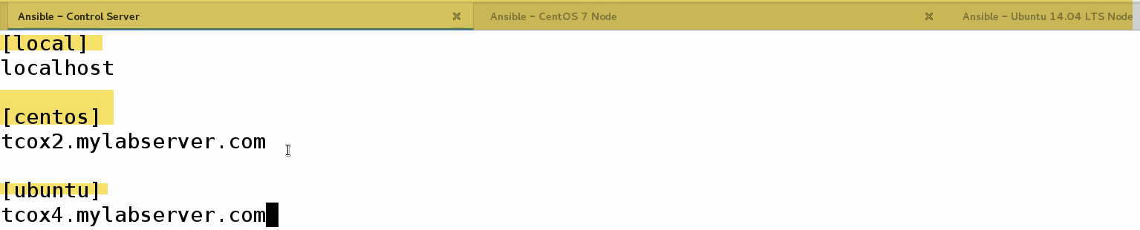

**We typically run Ansible commands as sudo user**

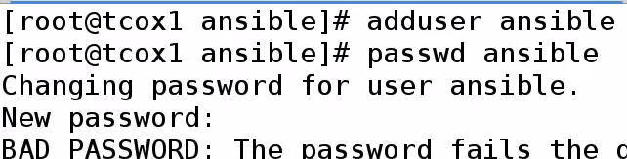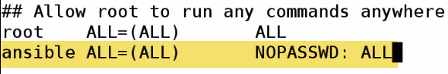**We need to create user accounts on each of nodes that we are going to manage with Ansible**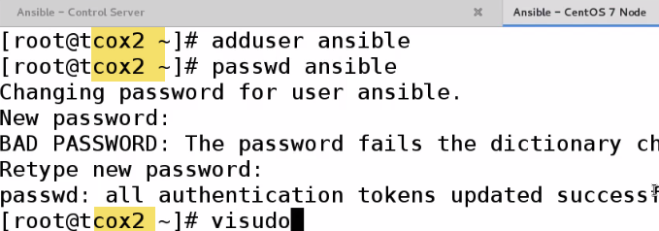

Since we operate over ssh, and we will not be passing password using sudo.

We can password..however we run playbooks as part of cron job, Jenkins job..So we don’t want to provide password.

**We have to setup ssh keygen:(WRONG BE ANSIBLE UER)**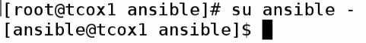 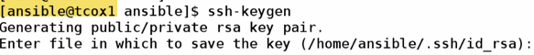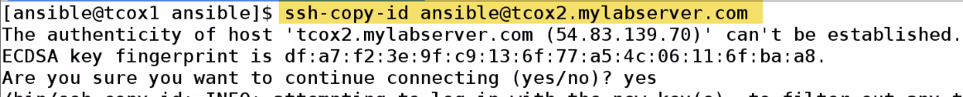

Now to Ubuntu: 

For localhosts: We need to copy-id to ourselves..Otherwise ssh to localhost fails without keyexchange..

**Even for connection to localhost will ask for password**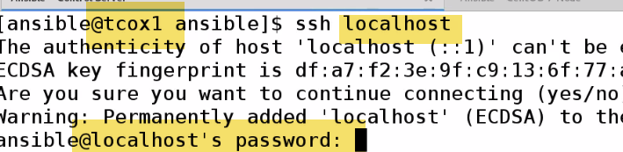



**Summary:** Installed Ansible and its dependencies

Made cople changes to Ansible.cfg

As there is no daemon running in Ansible, not required to restart. Ansible will read config file.., every time we run Ansible cmds.

Created hosts file, with 1 node in each group

Created Ansible user, and provided sudo user.

Exchanged keys nodes as well as local(Ansible server functions as local node) and nodes.

-🡪 Ansible Documentation:

**Docs.Ansible.com**🡪Owned by redhat..Certifications: 2---Ansible, Ansible Tower(Enterprise)—Reporting, graphing, with support

We already setup our inventory: /etc/hosts file which contains groups of individual nodes we may choose to run playbooks against... Inventory can contain Individual nodes, groups, patterns etc.

We can Ranges of Ips, ports, names..

Playbooks: Text file that contains YAML formatted options that tells Ansible what to do, what modules to run, what options to use in order to connect to Nodes to perform various work.

Playbooks run remotely through SSH on remote server..

Update Cache(repo) and install particular pkg: foo.

We can say install if absent, install update-to date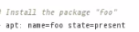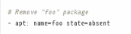

We will see simpler: install/update/remove users…

Let’s say I need to update simple config. On whole bunch of servers in my env.. I only want to run 1 command and update all. ..No need to complex like login to using ssh and udate all , setup..

As long as SSH setup, user and key exchange, can update/install pkgs across bunch of servers, And also. What distribution it is...

-🡪 Running Ansible Commands:

Cmd: Going to use Ansible module or not going to use module.

To do something on group of nodes or pull info. About node. This is similar to running playbook; however playbook is constructed in file..

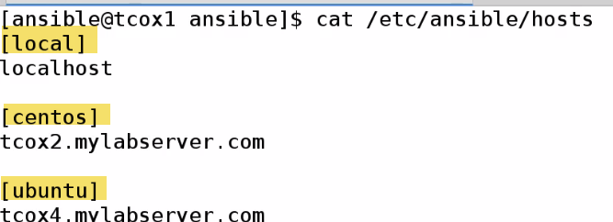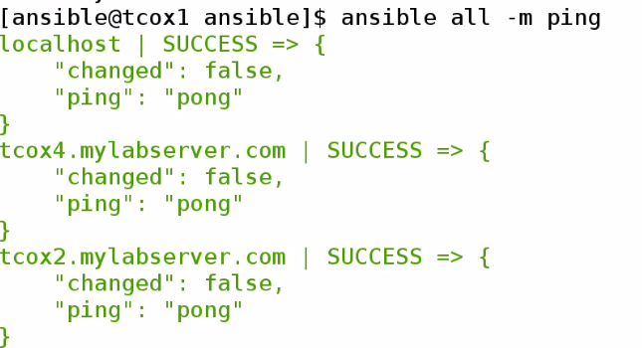all-> Run on all(default for all nodes on hostsfile)

-a🡪Run an arbitrary command (whatever is behind this parameter)

-m🡪Use following module (like ping). 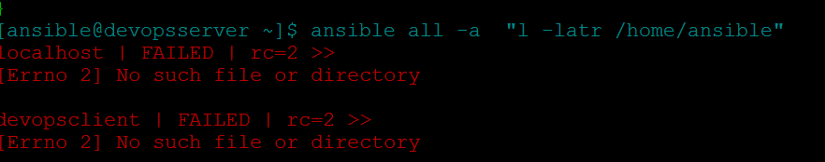

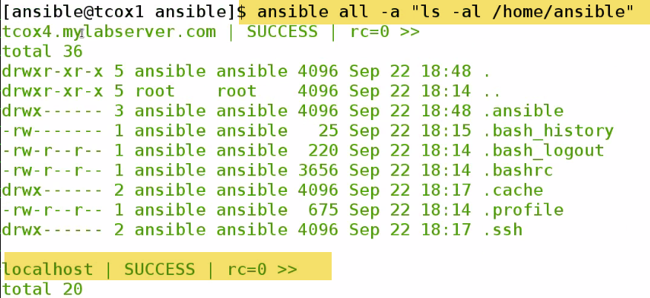

0-> success

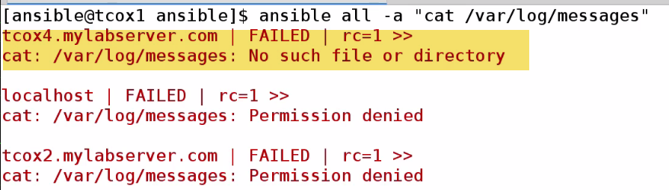

Root can only cat.. DO sudo

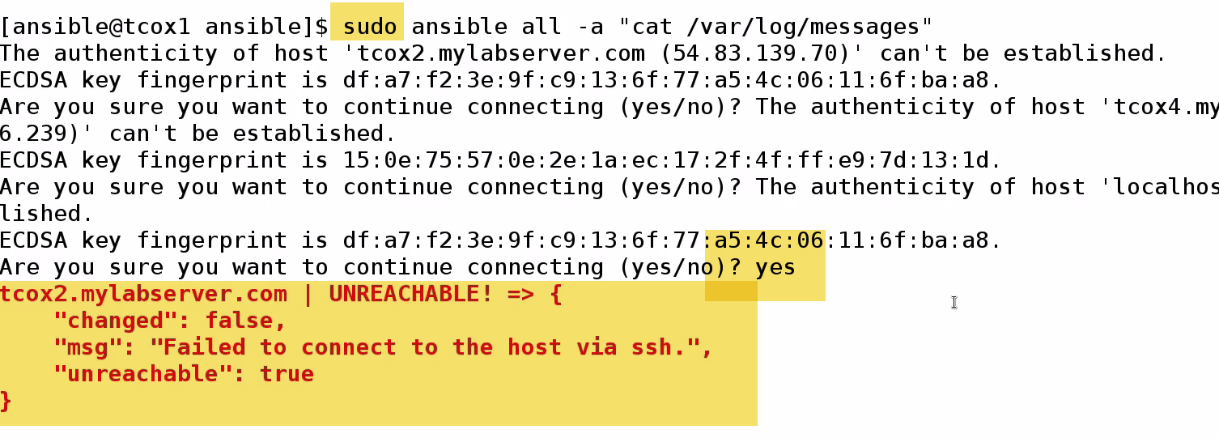

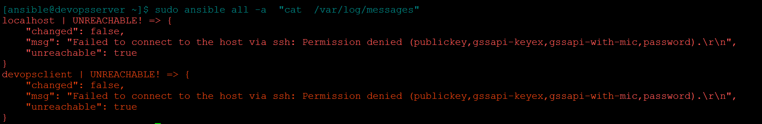

1.) It is asking for prompt

2.) Failing to connect using SSH??

Because, when I do sudo, it is trying to be as root user. I didn’t exchange root keys with individual nodes.

How to run privileged commands with Ansible user???

Why did we setup visudo (/etc/sudoers) –NOPASSWD???..Because there is facility in Ansible to use sudo root if we pass -s ..It will run command-elevating previlage of Ansible user to sudo(ASSUMING WE SET SUDO PRIVILEGES UP) on remote keys..And as we exchanged keys and indicated NOPASSWD…

-s

🡪Only on local

**COPY**

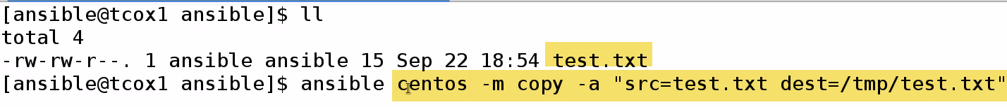

I have file test.txt

Execute command against Centos group(1 node) using module COPY with following attributes

Copying src file test.txt to dest file test.txt in /tmp dir.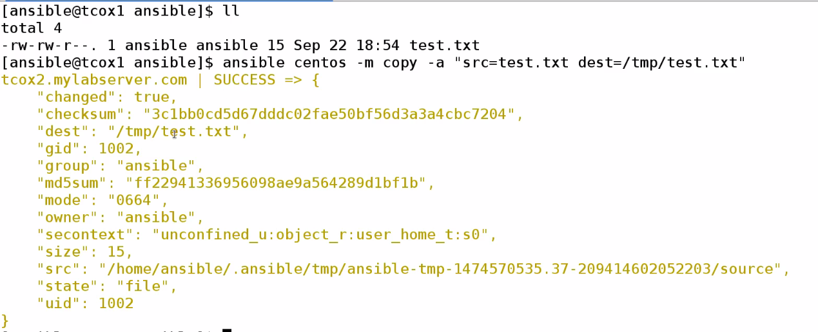

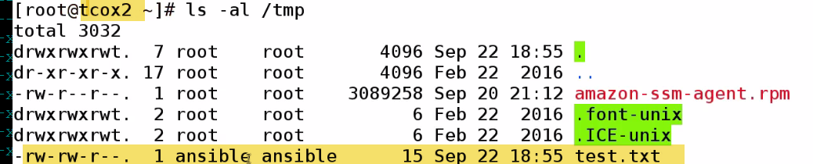

On Centos, see on /tmp test.txt created by Ansible user

🡪**Install pkgs**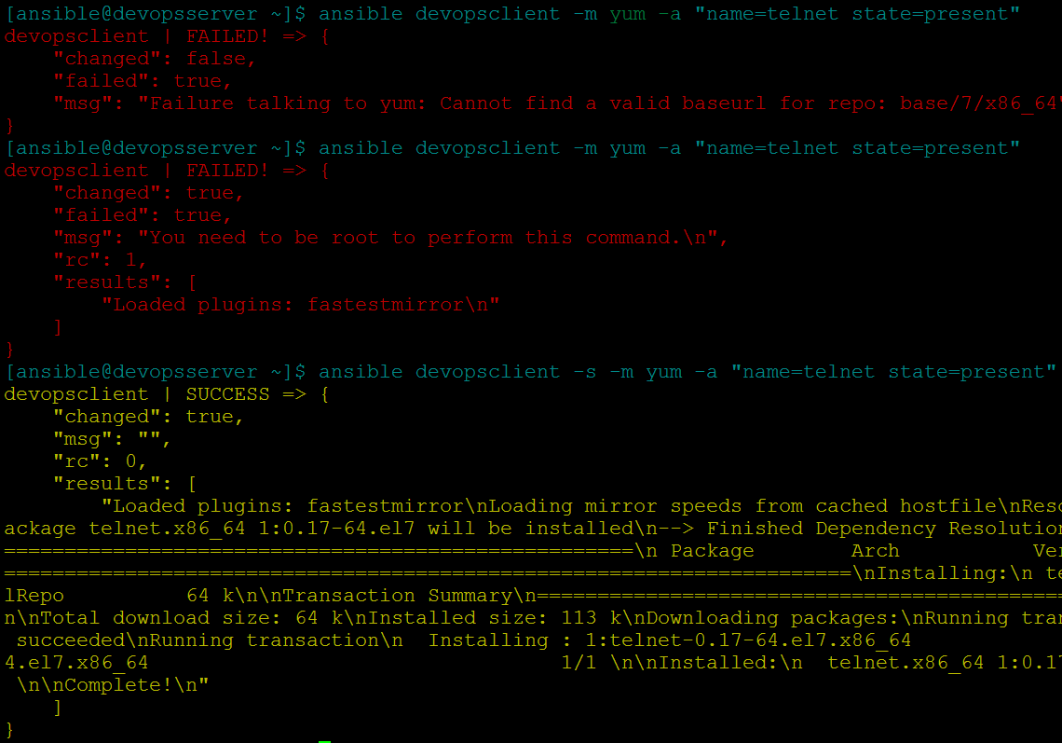

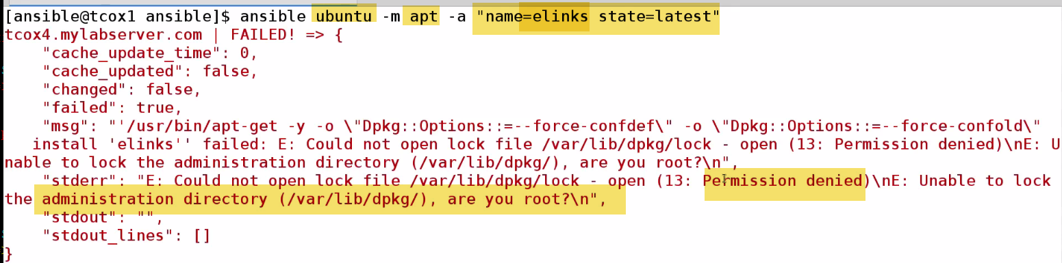

State=present🡪just install (Challenge: if we have old version of pkg, it will qualify as present, and wont get update..

**In most cases, we use latest…Use –s**

**Remove: State: Absent**



**Add User**

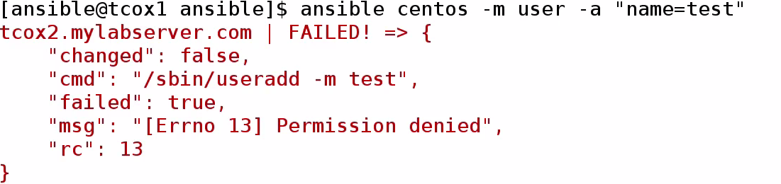

**Run a command**

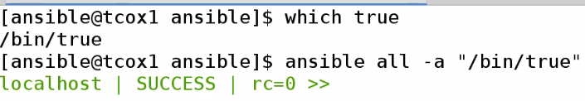

**-🡪Playbook Structure with YAML**

YAML: Key value list

Very Easy to read, which helps to define playbooks against nodes.

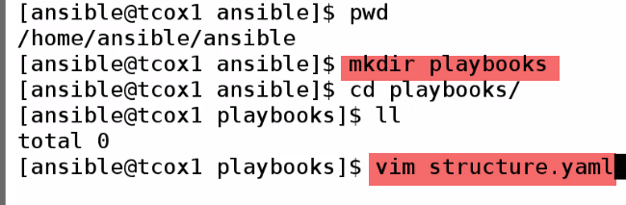

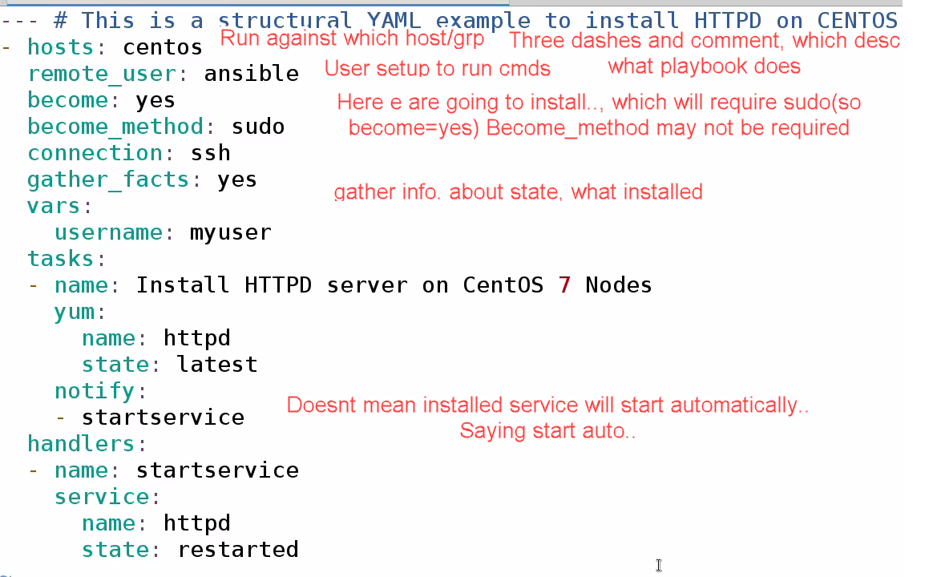

Everything is defined in sections..

Everyhing here belongs to hosts….Username belong to vars

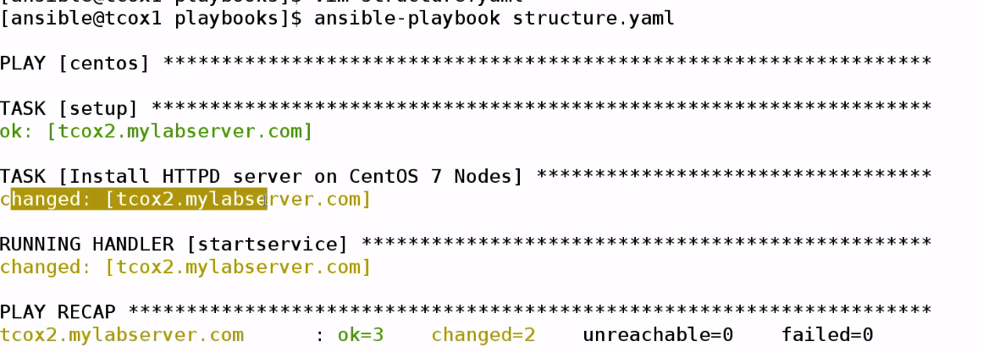

Playbook for Centos group is running..Task setup..Installing httpd—running startservice.

**2 Changes made : Install httpd, restart service**

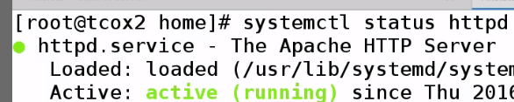

**-🡪 Gathering Facts**

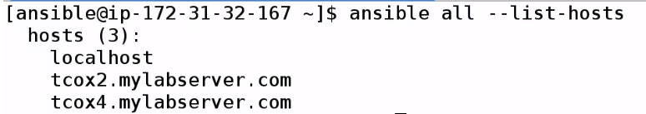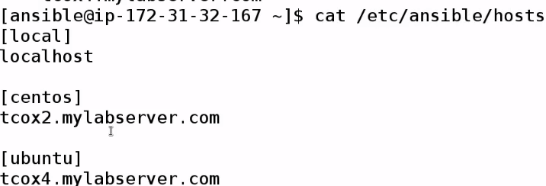

In playbook we mentioned, we can turn on or off gatheer facts

**_facts=(true) default**

Ansible needs to needs to determine someway, whether it can run plays asked to on remote nodes..

It goes and asks info. About that node..

We can explicitly get facts...if we want to..

****🡪It will gather facts by default when Ansible runs any playbook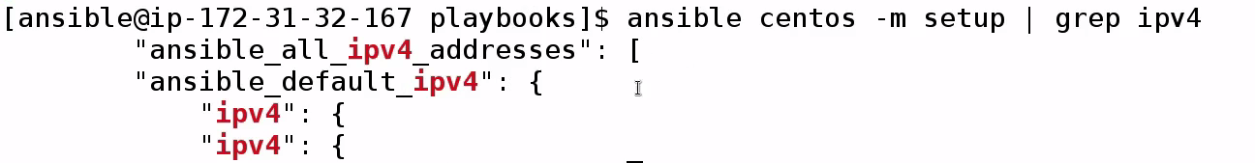

Actually lines in here..are in json -🡪 not good for grep---

FILTER SECTION THAT HAVE IPV4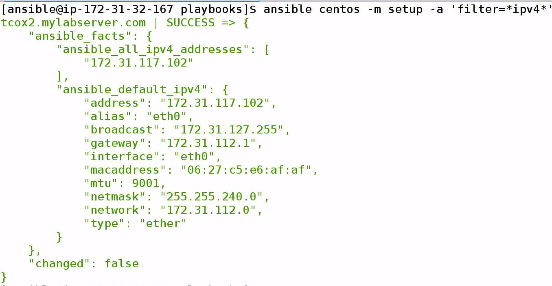

**🡪Create a localfile**

**Facts is output folder**

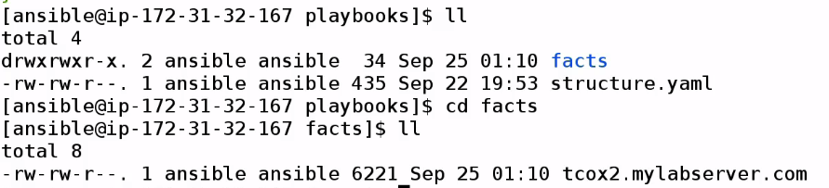

**Vim tcox2.mylabserver.com**



**Now, find key…We can use them in playbooks**

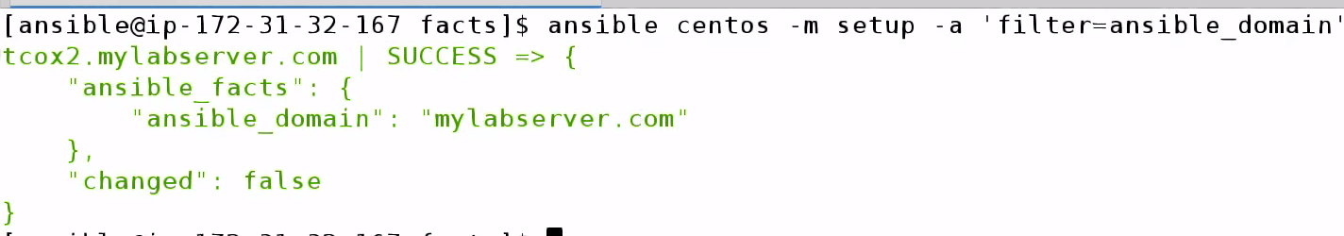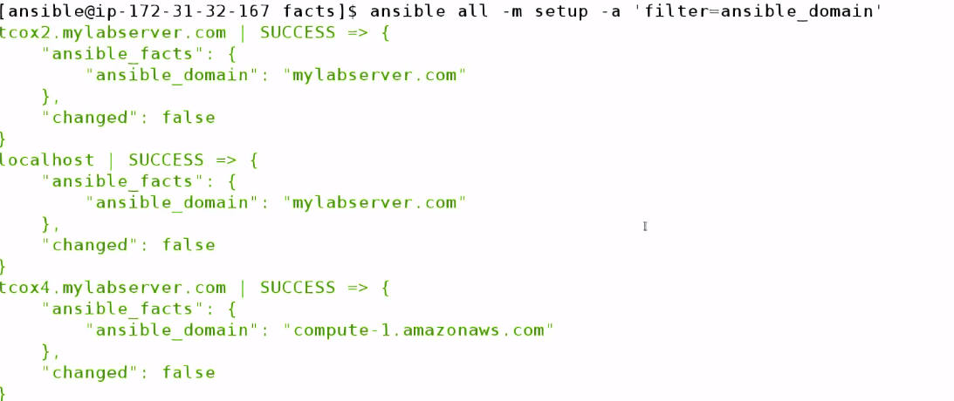

**-🡪 Variable Substitution**

**Variables can be used in playbooks in 2 ways:**

1. Variable section in playbook: So we can change once, instead of changing multiple times
2. Variable pass at run time

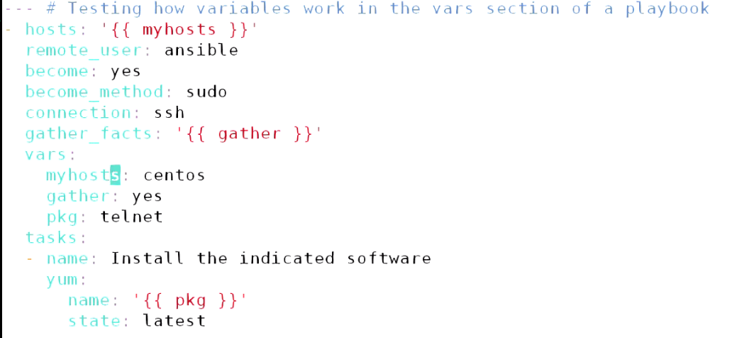

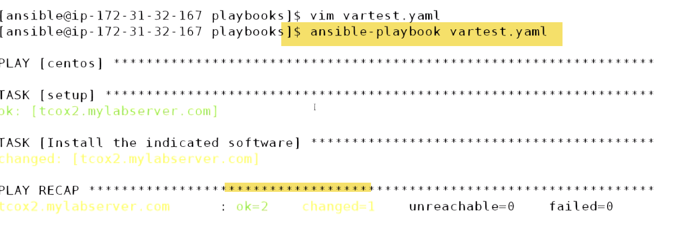



Command to centos group as sudo running yum module passing parameter telnet pkg to uninstall

1. Passing arguments

Remove variable section:

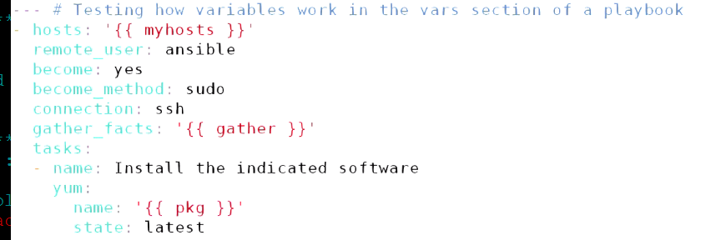



-🡪Debug Statement:

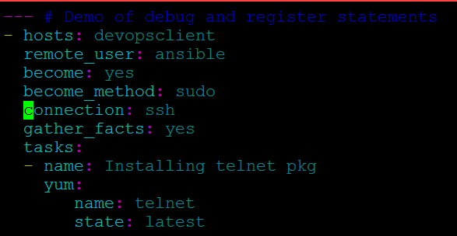

Let us say if we want to do on 100 servers or entire environment like upgrading.

I need to know:

-Which servers did not have pkg installed at all

- Which servers have software pkg updated

--If something expected happens??—I need to go to each client and check if telnet is installed

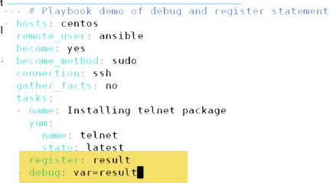

**-🡪Notifications and Handlers**

Ability to determine: When something run regardless of other event---Called as Notification and Handling.

While executing tasks within playbook and execute some control over(no need to use conditions) but it’s basicalaly saying if this thing run.. Run another thing. If 1st thing didn’t run..other will not run..

**Named as notification because: It fires off notification for section called as handler section to handle.**

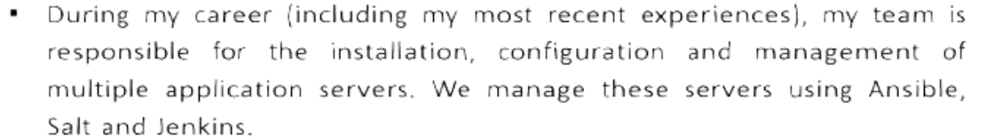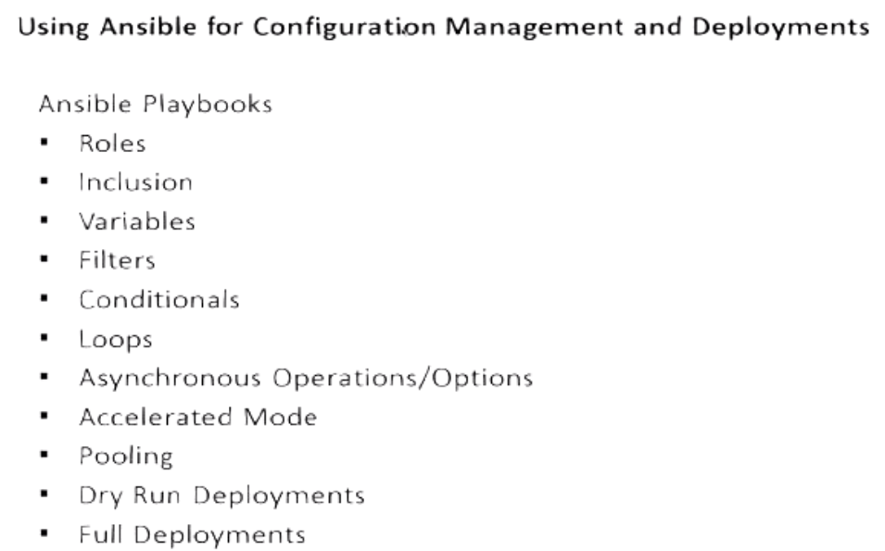

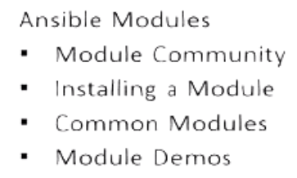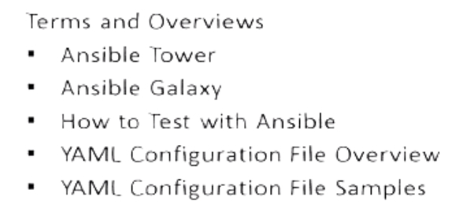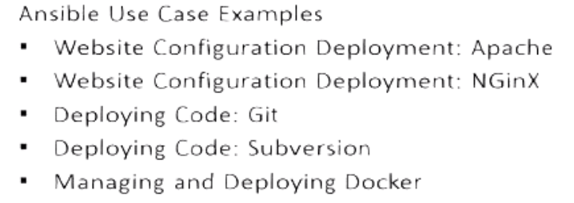

**Ansible Playbooks** are one or more scripts, which tell Ansible:

What to do

Where to do

How to do

What can be used to do it?

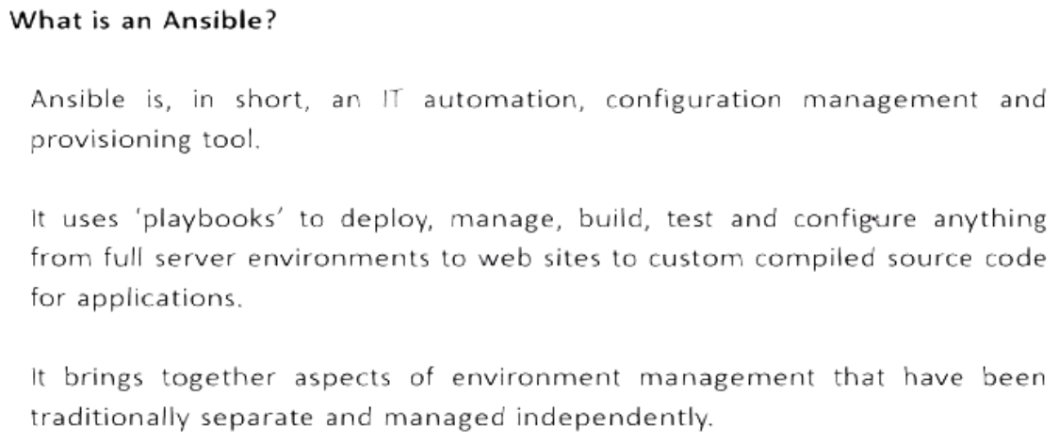

One stop shot for managing, deploying env..whether in Virtual, AWS, Azure or Openstack.

Configuring everything from OS deployment, Contsant deployment and delivery of Code Updates , builds

With Jenkins: In order to configure, Build, Test

With Docker: deploying and configuring Enterprise env. 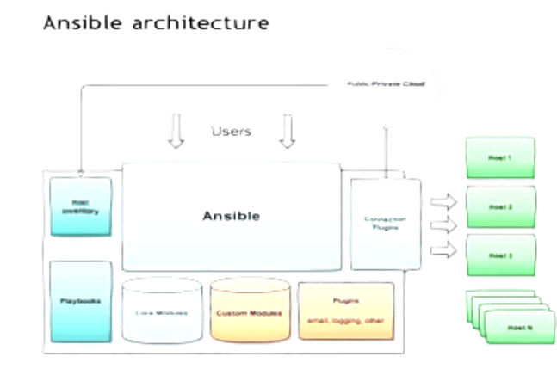

Every client can be a server.. Every server can be a client.. Config.

Server for 1 Config, Can be a client for other Config.

🡪With Ansible, we can make server deployment exactly same and consistent.

If we deploy webserver on centos7, every server is configured exactly same because same configuration is sent to each to these servers, when it spin up.

-- This ensures we haven’t introduced anything by manual configuration.. Which may cause hardly to troubleshoot.

--Additionally, may make up into system or environment issue. If system is mis-behaving there is no need to troubleshoot, we can reapply configuration. Pull node completely out.

Ex: in a webserver env.., have 10 nodes in cluster.One node is misbehaving, 9 are fine.

There is no need to troubleshoot that whay node is misbehaving , I can pullout—destroy, and redeploy fresh instance and put in my cluster.. My consistent config. Is going to heal my new node..

__--🡪 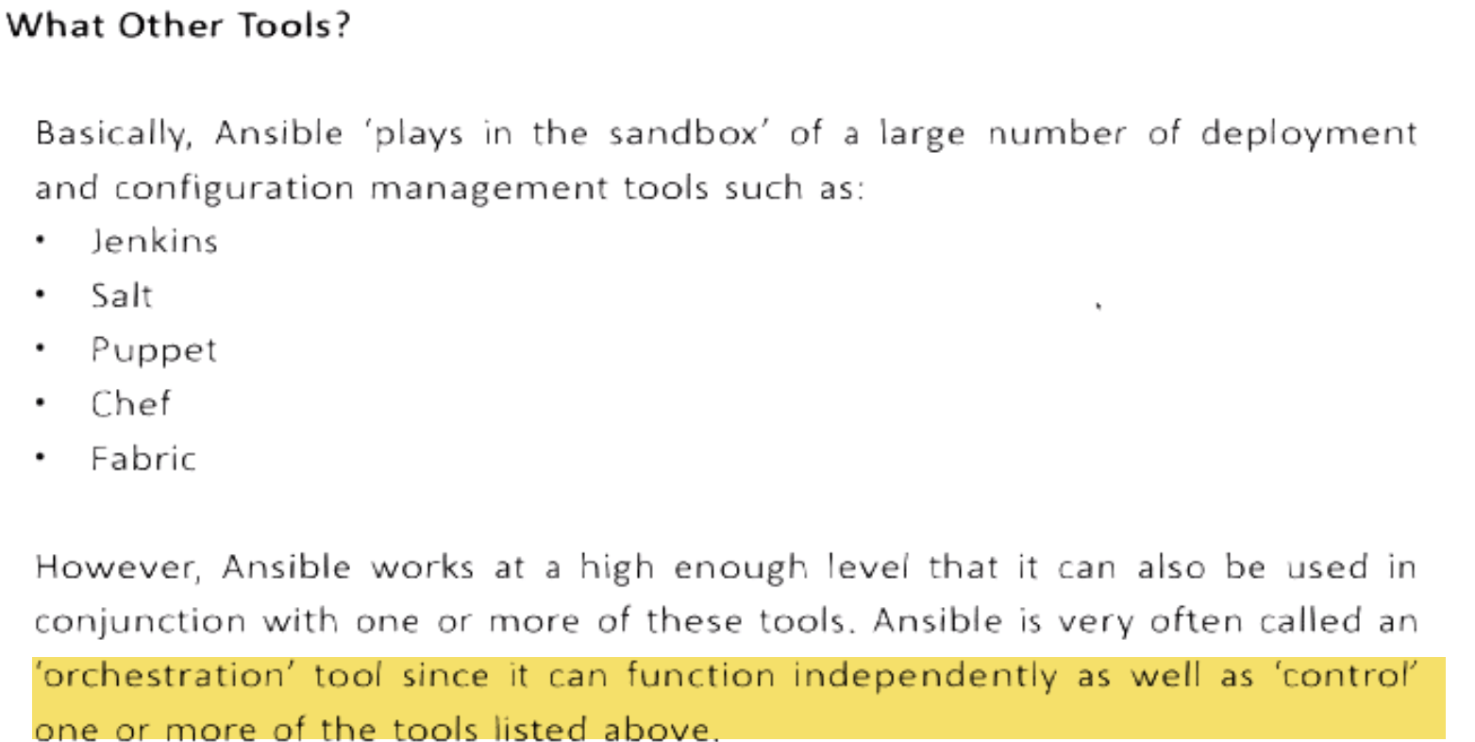

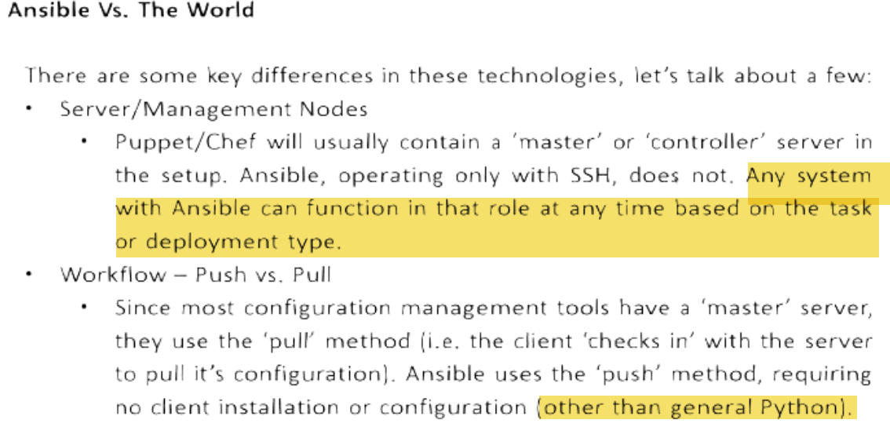 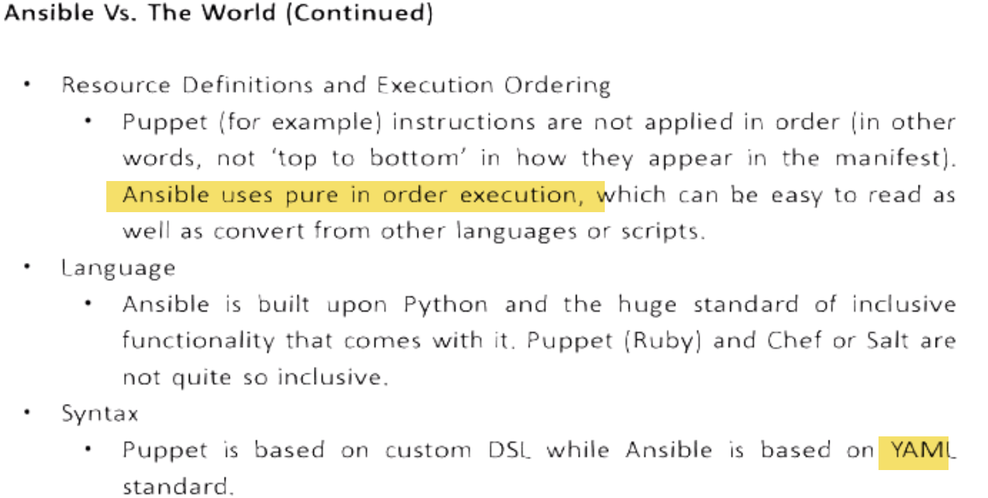

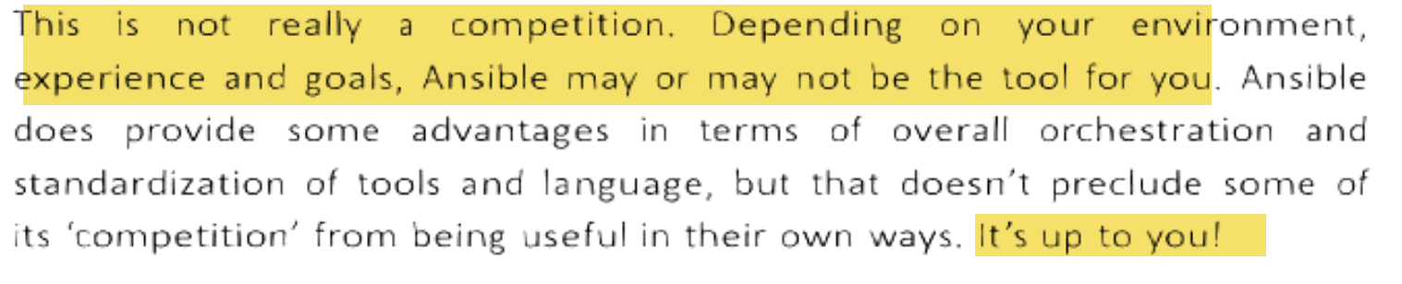



 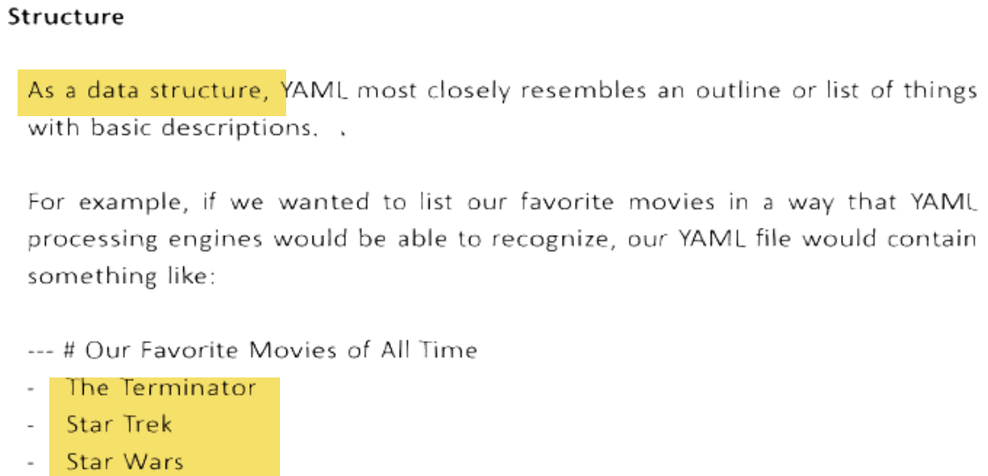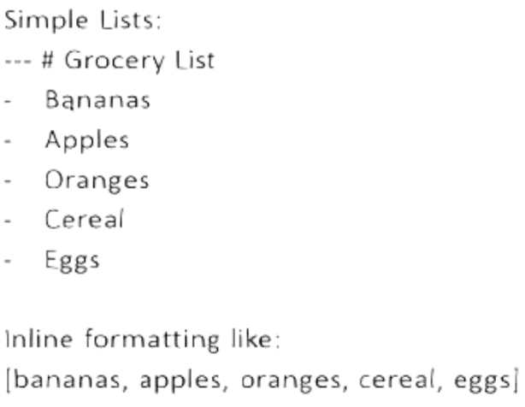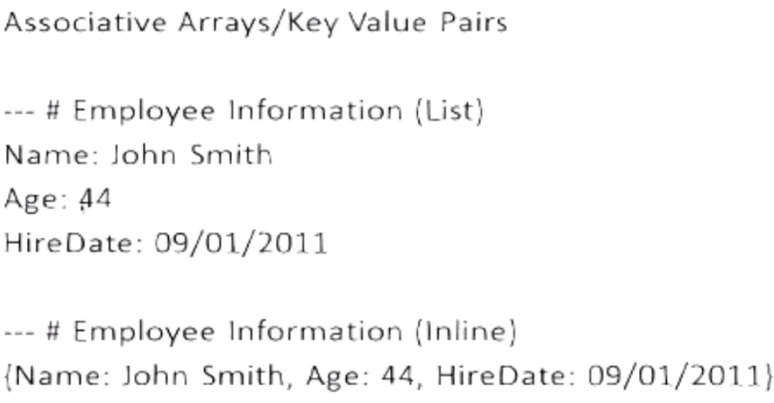



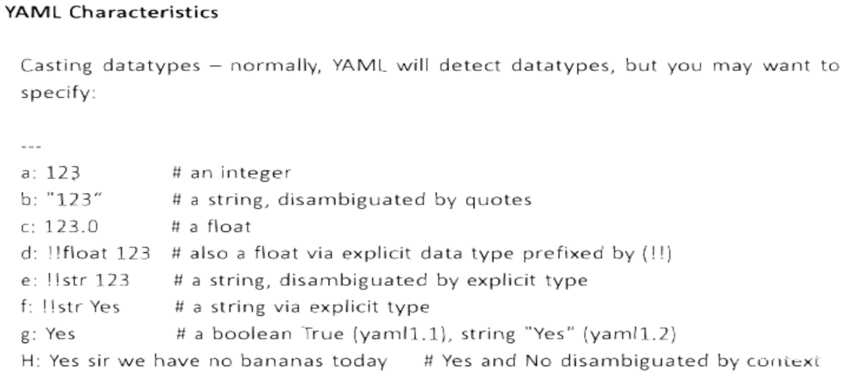

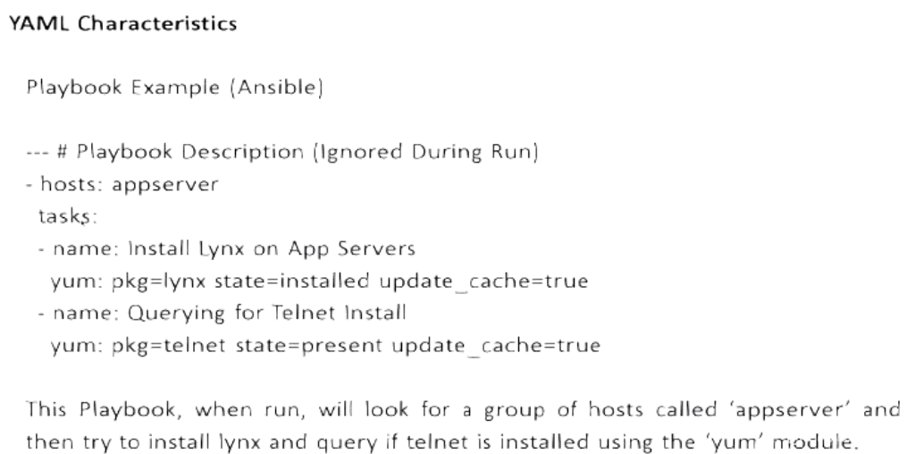

**HELP**

Man Ansible

Man Ansible-doc

Ansible-doc –list

Ansible-doc –list>list---will be helpful

Ansible-doc ec2

**Ansibe tower-🡪enterprise edition🡪reports**



**Use python 2.6 ..Not python 3(Can cause problems)**

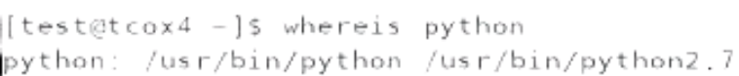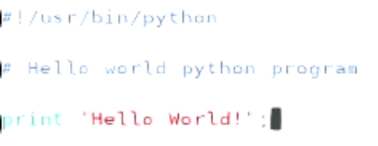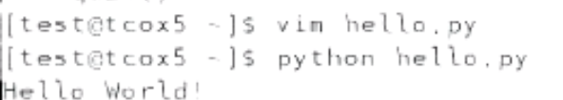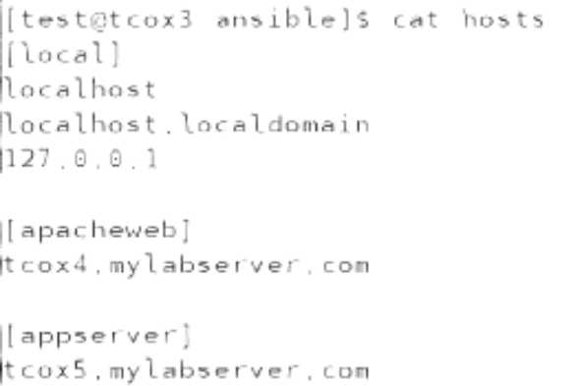 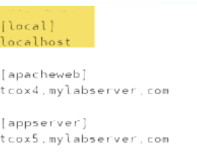

**Note:**

Ansible Config. Under /etc/ansible

Recommend: Setup shared n/w drive so that we can execute playbooks from any.

Ansible can be configured to run by root or user.

🡪 When we refer something locally, no eed to refer 3times in example..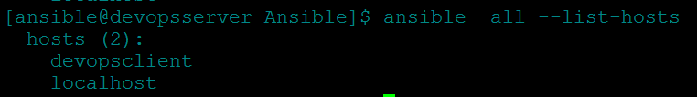

--🡪Override hosts file---Create hosts file at any place

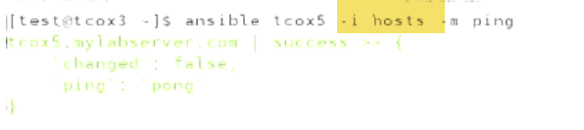

🡪How to overrirde /etc/ansible/ansible.cfg???

* IF I DON’T HAVE SUDO PRIVILEGES TO CHANGE ANSIBLE CONFIG FILE
* What if I want to define group of hosts that include in main hosts file

🡪1.) a.)Instead of 

We can copy ansible.cfg locally and

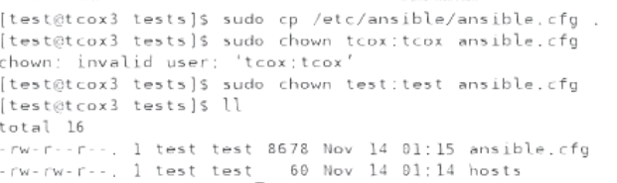

b.) Change inventory path to ./hosts (Current dir…hosts file)



c.) It will use current dir. hosts file

2.) If we change inventory path, need to set variable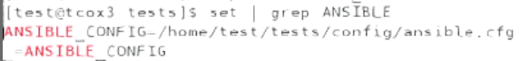

So 1st look for ANSIBLE_CONFIG env.

Variable..2nd place current dir, wherever I ‘m running command

3rd: home dir of user running command

4th: /etc/ansible/ansible.cfg

🡪Roles

Ansible.cfg



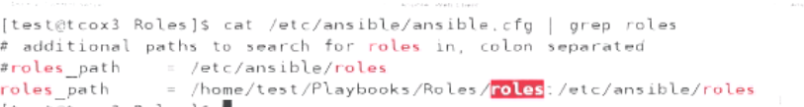

No password will be asked, when running using sudo



--🡪

Check if nodes have telnet installed

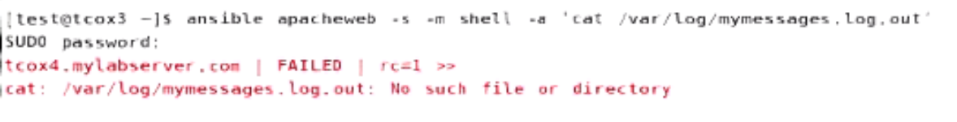

If command fails…RED

-🡪Check if ansible is able to run commands.

Ansible gather_facts using setup

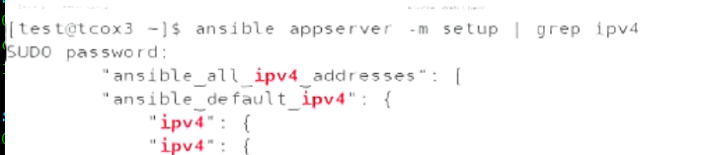

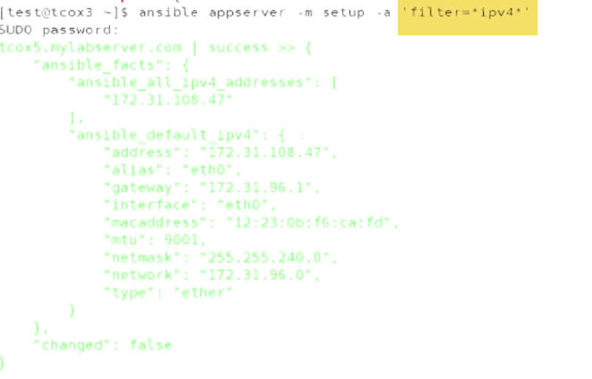

**\*ipv4\***

**-🡪**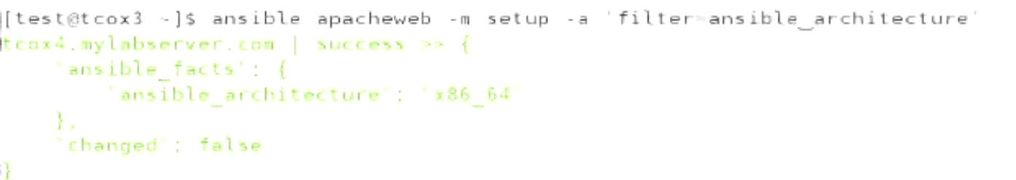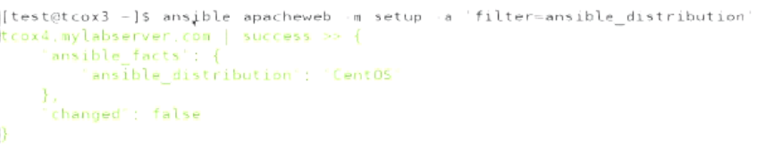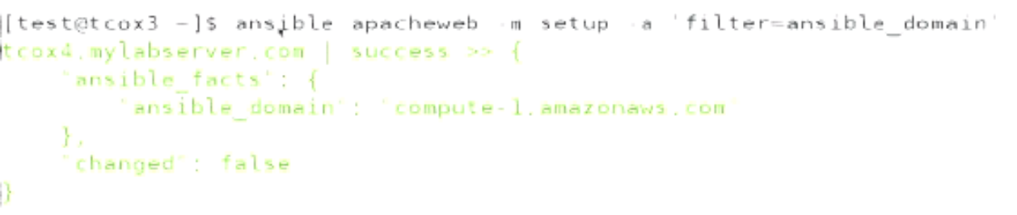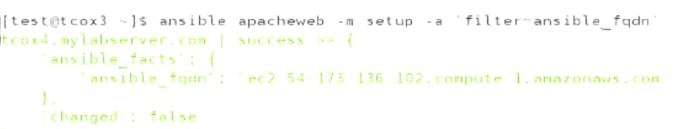



**-🡪**

**How to convert this into playbook???**

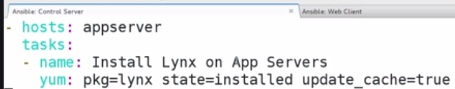

**🡪 If we want to run yum update.**

**We can do using cron job**

**-🡪Variable(Included as section vs included in file)**

Ansible execute from top to bottom.

Variables should me defined on top under vars section..Otherwise undefined

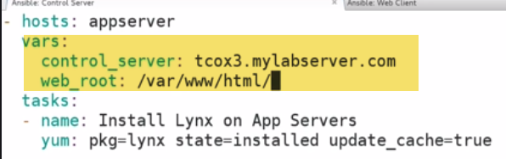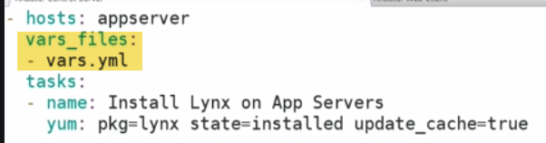

I can have variable defined in vars section as well..

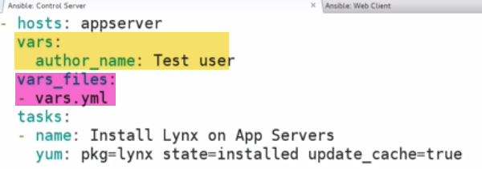

-🡪**Tells who(test user) to run, how to run(sudo) at target**

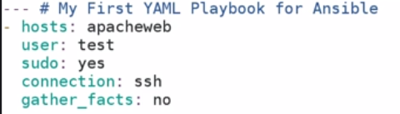

🡪Playbook-1:

1.)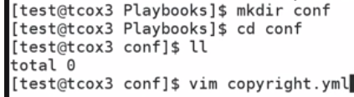 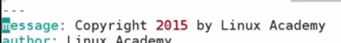

2.) 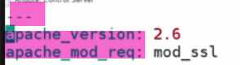

3.) 

It have 3 types of vars:

* var(within playbook)
* Var: outside(external file)
* Var: Populated at run-time prompted by ansible itself

Issue: 

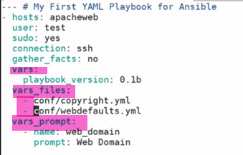

Anything that is external we have to use – before…Local not required.

-🡪

Number of modules:



Tasks: What we are going to do/actions in playbook.

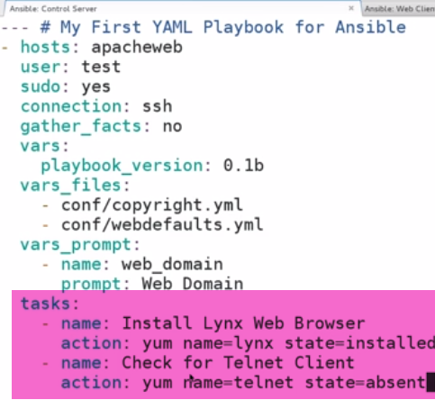

-🡪**Handlers:**

**Has 2 things**

1.) Ability to notify when something happens

2.) Execute another set of tasks.

Although not a task, it’s a kind of own handler.

Something happens, Something is notified that thing happened…, Something happens as a result

If notification/action doenst takes place, then handler wont actually execute that particular action…

1. **Ex: install httpd and restart service**

Don’t configure handler if we want to run everytime in playbook..(Handlers run only 1st time) 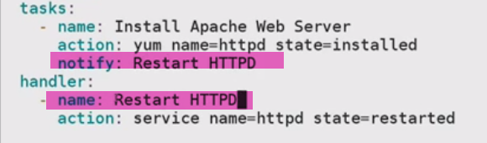

Install apache using yum module…Once installed we can do notification, which says once this is installed…, I want to do something

So, task is going to install Apache webserver.., and then going to create handler that will allows us to handle that event.., and take action on it.

All we have to do is: Set an handler ---Restart Httpd

--🡪Instsall apache using yum moduele.., make sure it is installed…Notify restart httpd.

NOTE: Only way to ensure it is called is notification have to mATch Name of handler

Not running now: 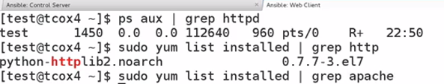

Runplaybook: 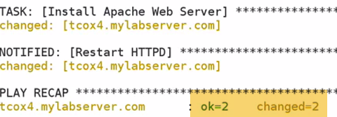-🡪 2 chnages(both ran)(running)…

Now, if we run playbook again.., Notification doesn’t run

Since there is no installation now(laready done)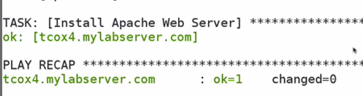-🡪Doesn’t execute notification event,because it didn’t make anychange this time.

If change doesn’t need to made, then notification wont be thrown.

-🡪Outlying your Playbook

Determine how to layout playbooks…

We can use standard notation for us to taker notes..That gives us thinking what to do…So that we can creaTe PLAYBOOKs.

Now we are going to create basic outine in text editor.., that says what things we have to do…And then create playbook..And make sure results are achieved.

|  |
| --- |
| Perform task on Webservers  - Webservers  User going to use  - Test user  Install software, so sudo rights  -date time-stamp, so that we know when playbook is running  -Install webssphere  -start webservice  -verify webservice is running  --Install clinet softwre like telnet,elinks  --log all packages inatlled on system  --Date/time when playbook ends |

-🡪Create playbook from outline

Since yaml is a markup language, we are going to translate exactly what we id in editor to playbook, that run osn end server..

**ansible-playbook webserver1.yaml –check-🡪formattted correctly/not**

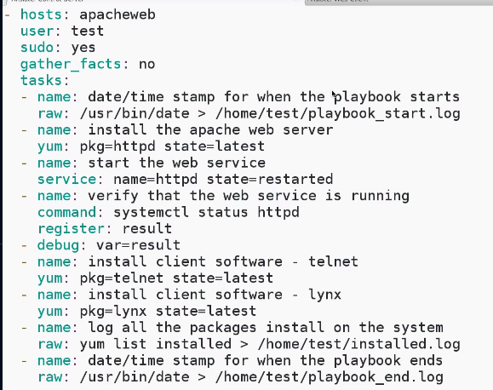

-🡪Optimizing tour playbook

1.)Disadavnatge of rae: It downt have ability to register result.

Use ‘Command’ module

2.)Notify---handlers, run only if yum command succeeds.

If yum didn’t run or doesn’t needs to be installed,Handlers starting httpd isnt going to run..

So we end up with Webservice is running..

Note: If we don’t use this handler,webservice will be restrated, everytime we run this playbook

3.)We replaced modules with apropriate

Optimized, to bring JSON formatted output, from commands we run..\

Start httpd, when httpd is installed only

Write output to DB, so that we can know what Playbook is doing

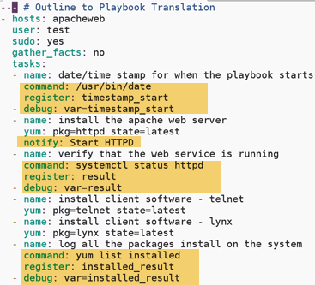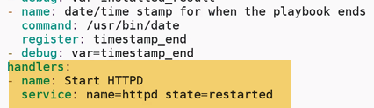





12 commands now, reason why 8 before???...When running command that cant be excuted using Shell(dry run check)…It will indicate that’s it’s not available to be checked

--🡪Taking our playbooks for dry run:

Determine if both syntax, and what we are going to configyre is correct, and it is going to run successfully….DRY RUN



It will check syntax..,Connect to remote listed in playbook, and will look at what it needs to do for every tasks.., and what results might be..

What it wouldn’t do is: live captured o/p of commands in register/debug statement..You wont get back in JSAOn format, as there isnt ant format to capture 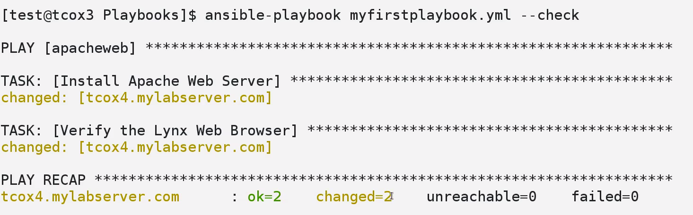-🡪2 changes

1. Check if Apache can be installed…Tells us Appache is not installed
2. Verify lynx webbrowser…Change: It will install, as not installed

So 2 ciommands, and made 2 changes

**--🡪Installed Appaache----ok**

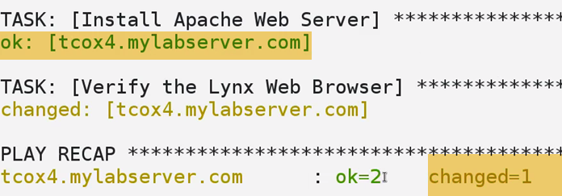--🡪change=1

Both commands will be executeed.., but only 1 change is needed.

-🡪Asychronous Polling( Running operations in parallel)

How playbooks runs in general???

By default ansible does forking upto 5 times=🡺 it will run operation on 5 different machines at one time.

However, if yoy find to have large number of machines..,or more constrained enviornment.., You have to lower value in ansible.cfg ..Then we have to launch things asyncronously.

How will do is…Start job across all req. m/c …Using max. forks and we will pull for completion.

There are 2 keywords for running operations in parallel…aync and pull keywords

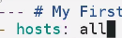-🡪 We are going to run on all inc. local host.

To force to run in parallel :in tasks sextion.., we have to do is…

Right after action/command..indicate when command is completed.

**For ex: Run ayncronouslly..So async keyword helps to run jobs in parallel.And value is max. time that ansible will wait for command to complete. Say: 300.**

**Poll: how often to check command is completed say: every 3 sec.**

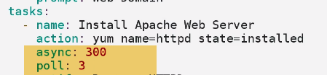

**Now, what we actually going to elongate time it actually takes to run across our servers,because we are running in paraellel..We are waiting to hold them.**

**We will remove this section,once we are done. But if we have extremely arge number of servers that we arae going to use from single control server ..,You want to put asyncronously polling ..so we don’t want to fork many times inorder for env. In realistic time-frame.**

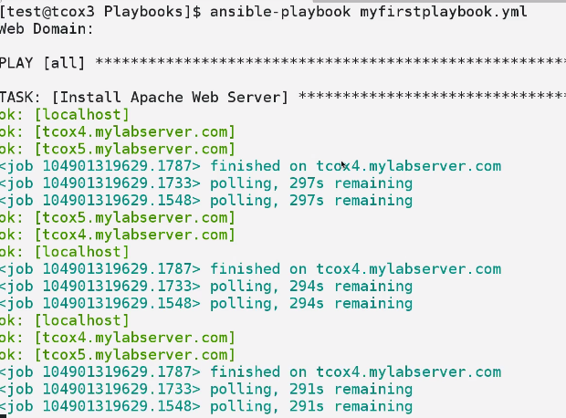

**Againt all…Installing webserver**

**Started job on each of 3 hosts(localhost, 3,5)..and it’s going to poll 300 sec waiting for those commands to finish.**

***IT picks each once, as it cocmpletes polling…waiting 10 sec b/w each polling..Going for 300 sec for polling to complete.***

***It takes x amount of time for each of jobs to finish in my environment..Across all servers I have.***

***Not only about, tracking on how long it takes.., But also break jobs and restrted concurrently.***

***My control server doesn’t get overloaed by forking process so many time.. doing at same time.***

***If we long running tasks…That’s jow we are going to do it.***

***Ex: Data base restore, Update across large number of DB and clusters..This will be a perfect example for Ansible poliing asyncronously.Because it may time time from sec, min, hrs time to complete .., And don’t want Ansible from holding Other jobs from within a complicated Playbook.***

***-🡪Simple Variable Substitution***

Varibale section, local to playbook itself..We have externalized content included for config. directory for including YAML files..that have list of variables, And we have prompt for particular value.

How to use external variable???

1.) If package cjhanges overtime… 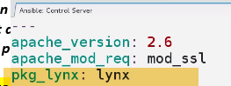

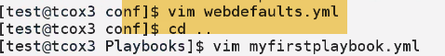--🡪External variable written on webdefaults.xml

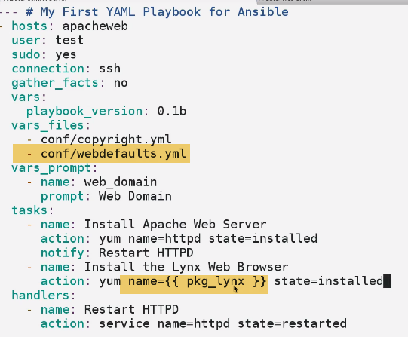-🡪Used variable here ….{ var }

**Not much practical example…**

2.)Flexiable…

---Used for An aplication changing rpm versions, or services change

Prompt me for package name , and I can type nay package I want to install

**It has now ability to dynamicalaly prompt package .**

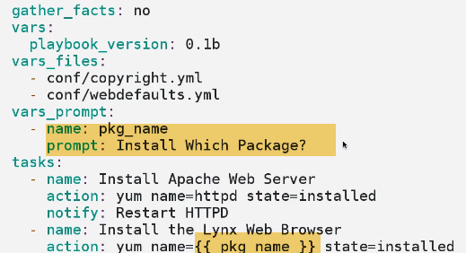**-🡪 Ask for input, dynamically from keyboard**

**-🡪Lookups**

Ansible equivilent of built-in function.It allows us to either lookup values and delimit file or environment .

Sepecially for ansible newer versions defined ini file.

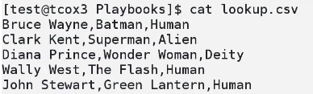-🡪 3 fields

1.)



By default, it ill return next closest matching column.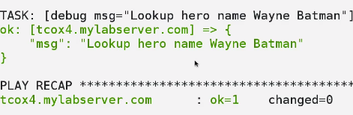

2.)Which doesn’t’t exist🡪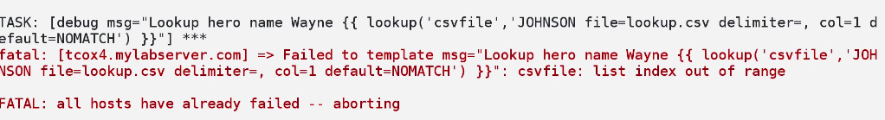

1. -🡪Lookup of env. Variable

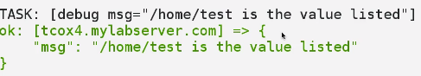---Possibly best useful case to use lookup

Ex: Getting values for Apache tomcat/webserver.

-🡪RunOnce

That can be added to any task.Any command that we are running.., we can add value to it “runonce”.

Because in complex playbook, we may run a playbook that contains 100’s of commands that each need to be run on one or likely a group of servers, we have defined..from within our systems.

However,there can be command that needs to run onlyonce …Deosnt matter which server runs on .

EX: 1st one on group .It only needs to run once.That’s because config. file meant to be for apache/nginx..That particular server serves as Proxy for other servers for load balancing env.

So we only want to runonce.

We don’t need to write sperate playbook to just run one command.

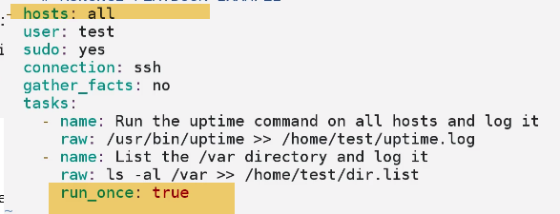-🡪it will list dir. only on tcox4

Run on 1st server…One time ..Defined on group of hosts(all here) 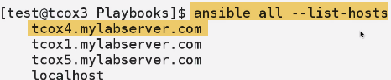-🡪Tcox4 is first one in list

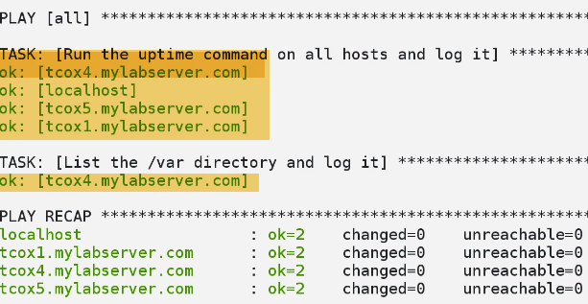it will list dir. only on tcox4, which have directory listing ---dir.log

Let’s say I’m deploying to 100 webhosts.., We have 1 host running nginx as proxy/cahing engine like Squid.

That config. needs to run on only 1 host that you configured your playbook to run against.

And we don’t want separate playbook run for that configuration.

**-🡪Local Actions**

We can bypass ssh connection, user assosiated(no key required)

2 ways:

1. Connection-local(no ssh)

User will be user logged in

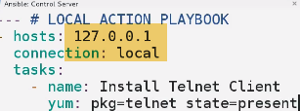

1. 

**-🡪LOOPS**

Need to do contaionally-🡪if, else conditions

Multiple times🡪loop

1. Add multiple users…User1, 2,…

Loop comes in, when we defines list of items that we are going to feed into single iteration of adding command to user.So module knows enough, when it sees the key of with_items to take all items individually listed from within here, and add them.

---No user1,user2,….on remote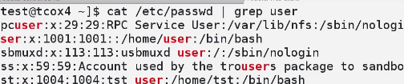

It’s going to add user, called user1,2,3,..Loop through this 3 times, And makes sure it Adds particular user.

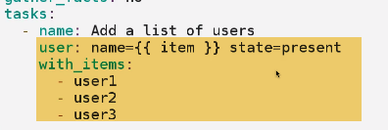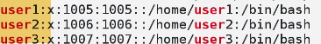

1. We could add group etc…

**-🡪Conditionals**

Install Apache on Centos /Ubuntu based on gather_facts section, that it is Debian/redhat system

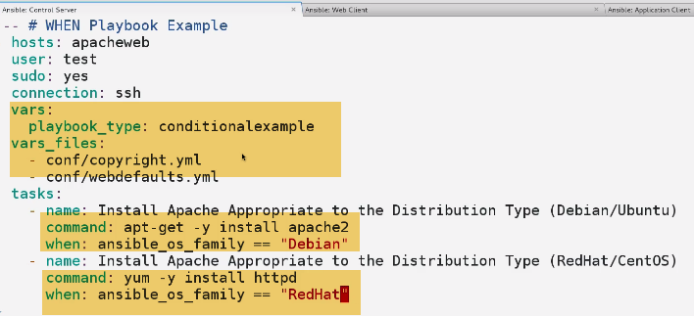

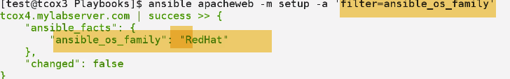

Apacheweb🡪rehdat🡪skipps Debian.

**-🡪Until**

We want to run particular command until something changes.

EX: test for particular value.

Limit number of time, we want to retry that command., delay retied b/w command,.., register reuslt of that command..

1.)Run command until,result of std o/p, I can find avalue..Active, running

I will find this status Active, running..Somewhere in systemctl

UNTIL not getting faulure =🡺!=-1 or Until not negative

0🡪successful

1. Retry 5 time,
2. For sanity sake, delay each trial by 5 times..
3. Later debug, to display result
4. 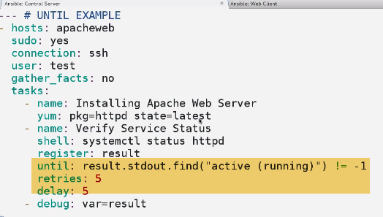

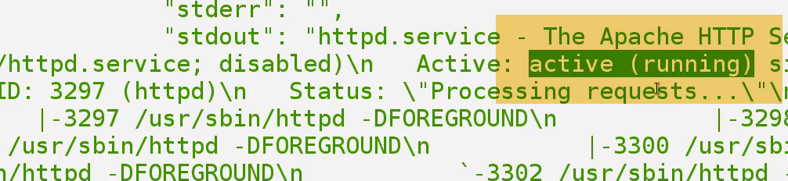

We will see somewhere in std o/p, we run

**-**🡪**NOTIFY**

**Handler consists of 2 pieces..**

1. **Install apache webserver.**
2. **Create handler, that allows to handle thate event..And take action on it.**

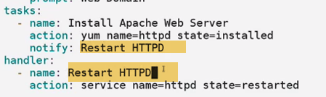

Handler runs only when…Yum task runs…

**-🡪Vault**

**Suppose we want to run plyabook using a specific user.., and may need to run password(sesnsitive)**

Encrypt ansible playbooks using vaults.

1. 

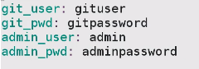

We can import these using vars/files (externally).

We can just cat filename and can know passwords.

1. We can use ansible-vault to encrypt multiple files.

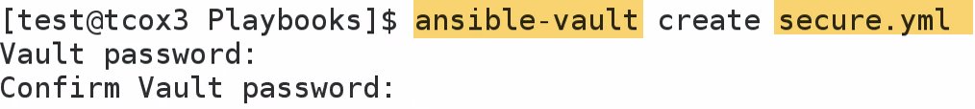

It will create a temporary file, on temporary location.., and encrypts on exit

 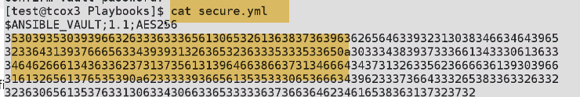

It is encrypted with AES encyption.

1. To edit 

-🡪 it will give values in that file

4.) To change passowrd on vault encrypted file.. 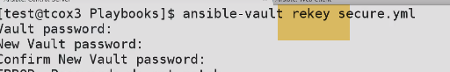

5.) Unecypt: 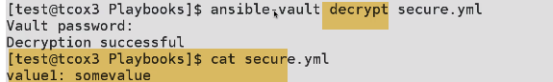

----------------------------EXAMPLE_------------------------------

1. Now.., 



We can import these using vars/files (externally).

2.) 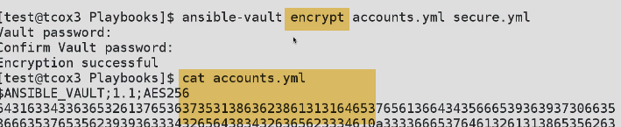

Encrypt can be given for multiple files..

Vault password applied for multiple files.

We run run playbook, that encrypt any of these encrypted files by simply passing ask vault password file.

**Prompt for passord **

**create a smple text file password.txt**

**-🡪Prompt - Interactive Playbook**

Pretty powerful for doing dynamic

Simply press enter-🡪default install here is telnet

Private=yes🡪whatever we type is not visible on screen

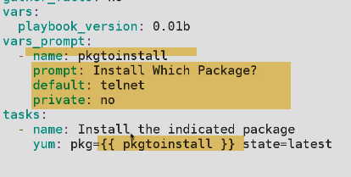

🡪private=no

🡪Just press enter here..

No input givesn…Default here ..telnet.

This helps us to get interactive input from command line, from user in continuos integration Model

Jenkins can send outut to Ansible playbook, based upon other criteria.

So Gathering info. dynamically from other places, and we might use variable prompt to gather info. based on output of other things that happen in CI model.

**-🡪Basic Include Statements**

**As playbooks become complex, we can break them into functions in the tasks into other files, that are either labelled or structured..**

**We may have large no. of packages or functions that does**

1. **Structure everything into single yaml playbook**
2. **Breakout functions into discrete files that are labelled and include them, as we need to .**

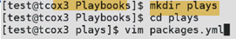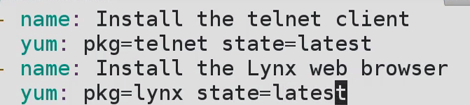

**This files have only this contents.**

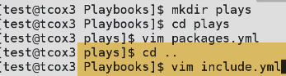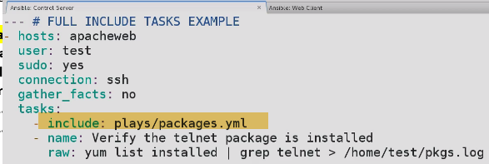

**We have packages.yaml included in plays dir**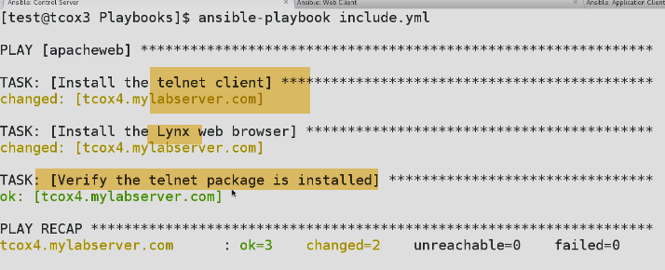

**In order they are done**

**🡪Tags**

**Gives ability to Dynamically control pieces of playbook we want o run**

**Ex: Install pkgs, and verify if those are installed.Using tags here to control, how playbook runs.**

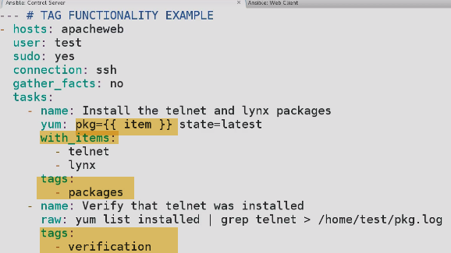

1. **Iterate 1 for telnet, 2nd for lynx**
2. **With tags-🡪verified**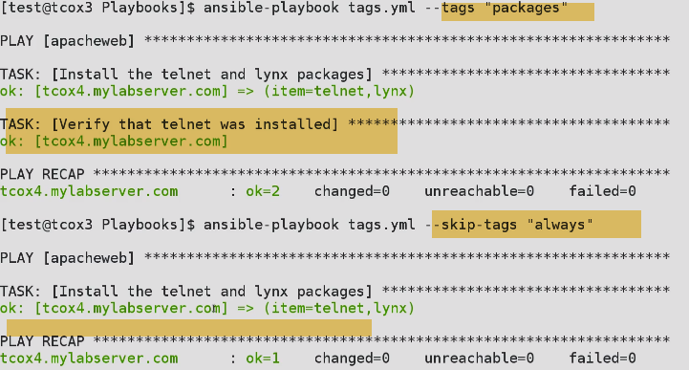
3. **Without tags-🡪not verified**

**Ex: install source code, and restrat webserver and other thinsgs ..I don’t need run 50 things, that make take a while.**

**Then I can just run playbook with tags ...**

**--🡪Basic Error Handling**

**Error handling: ignore, display some messages, register results, changes some values.**

1. **How to work with error from playbook???**

Generally, when we get error, playbook will stop executing any more steps on particular host that have failure.Howerver, we may sometimes want to continue on ..So we can write taks that allows us to that.

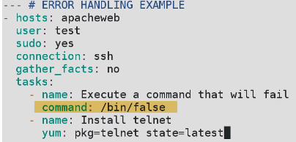

Normally if my /bin/false command fails..It should end..(without installing telnet).

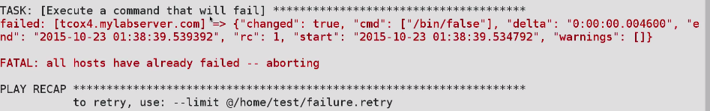

Here: /bin/false failed.. ..Telnet not installed.

1. Ran playbook with various failure within??..And not causing playbook to dropout

Ignore_errors: yes-🡪default(false)

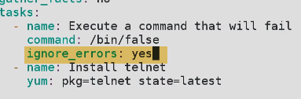

**Suppose, I want to intall webserver, and then I want to utilities that dependencies of webserver ..If libraries that deends on fails .. No need to go on rest of playbook.**

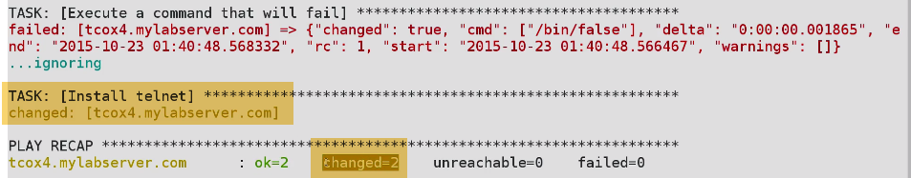

**2 changes🡪 1 command being command to ignore, 2 -> telnet**

**-🡪Includes - Breaking Your Playbook Into Discrete Plays**

**How to better structure a playbook.**

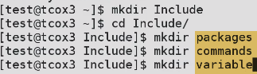 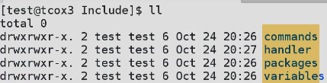

**Mkdir handler.**

1. **Packages**

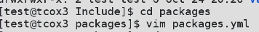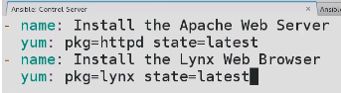

1. **Variables 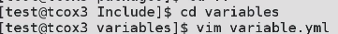 **
2. **Commands:** 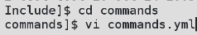
3. **handler**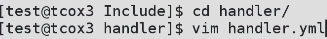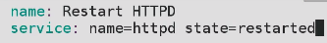
4. **Change packages.yaml to** 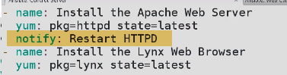
5. **Create a file webserver.yaml** 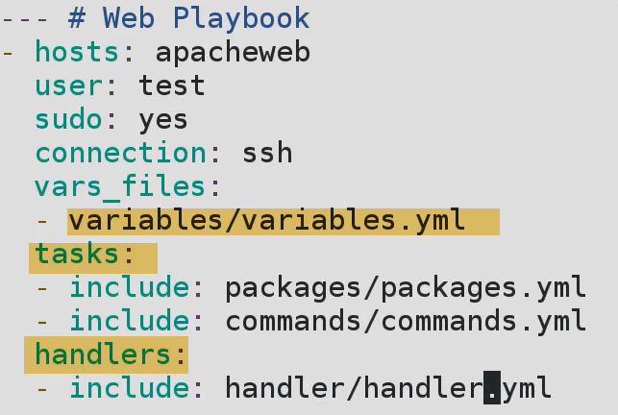

**We have plays, that can be re-use for different master control files or web files.**

**EX: I may have packages installed for webserver(packages.yml) in packages dir. ,**

**I have apt packages**

**I have proxy packages**

**I have web packages .**

**As I am going to create master files for discrete function, I can only include plays that are necessary.**

**It is good, but not as flexible as Roles**

**-🡪Starting At Task or Stepping Through All Tasks**

**Run parts of playbook, without necessarily run complate playbook.**

**Related to tags for unning specific parts of playbook.**

**We can also see how we can cause inserting playbook, without inserting prompt or debug statements that step us through tasks.**

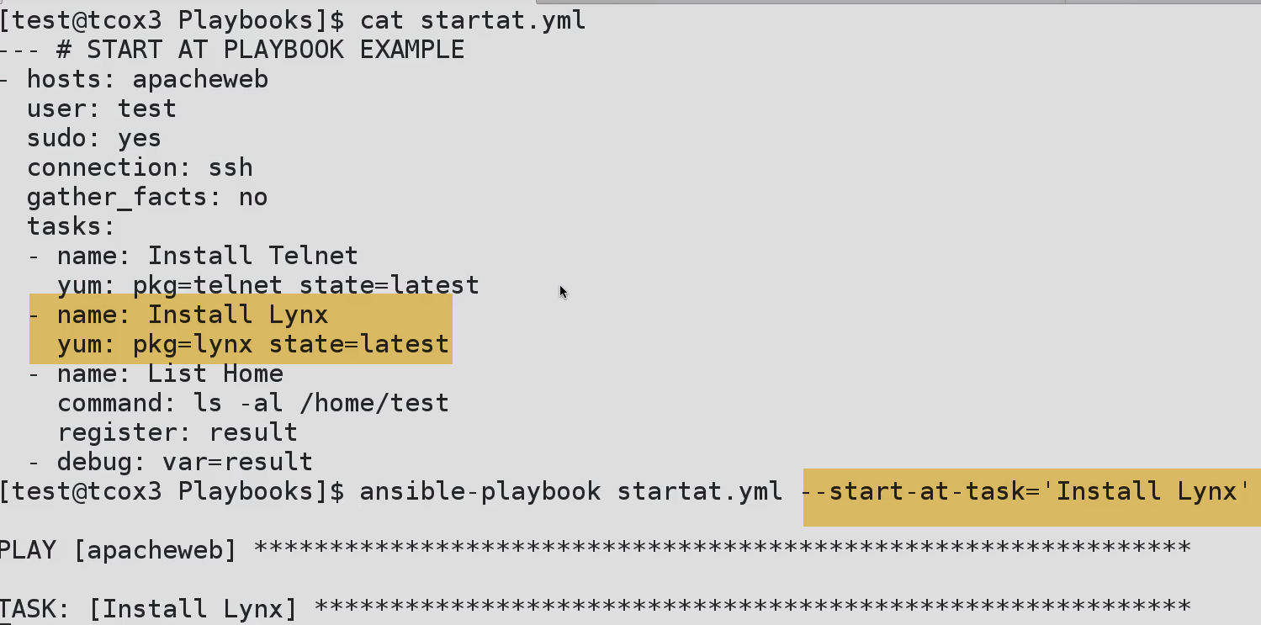

**Starts at Lynx, skips Telnet…>(Execution start from lynx)**

**After lyns, continues rest.**

1. **Step me through** 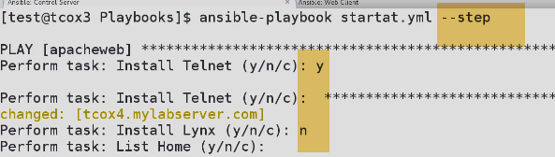

**-🡪Passing Variables Into Playbooks at the Command Line**

**1.) How we can use from playbook themselves**

**2.) Load var. from file**

**3.) Prompting for var., and user entering imput**

**4.)Pass var. from command line**

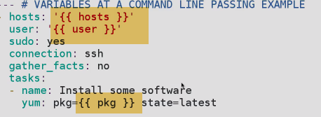**---Under hosts, user….Use ‘ ‘**

**Under packages ---fine**



**--🡪 Allows to genrerate a very abstarct playbook and passin info. based on group, pkgs etc..**

**-🡪Creating a Jinja2 Template File**

**Allows ability to define a config. file that can contain dynamic content.**

1. **How to create a template to use in playbook**

**Ansible based on python.Jinja2 is extension of python that alows to templatize configuration files that can pull in variables from variety of diff. locations.**

**-🡪'Template' Module**

**-🡪 Using Jinja2 Templates**

**-🡪 LocalAction(similar to deletegate to)**

We can use playbook and delegate certain tasks,that allows to delegate certain tasks that will some or other playbook indicates in hosts section.

If we going to delgate to run on local hosts,that’s called localaction

--Test DB connection.

--Remove something from a cluster of servers

---Pull code

--Backup database

--Shutdown DB instance.

**There may be many number of scripts, utilities locally that you don’t want to copy remotely.**

**Keep at one place, and want to clutteer up remote FS, by copying nd running there.**

**You don’t want to run from server that you are connecting to.., So you can keep scripts that you want to run locally and designate localhost to run that particular script/command.**

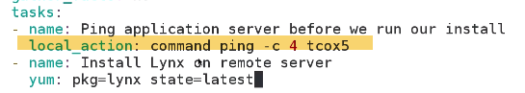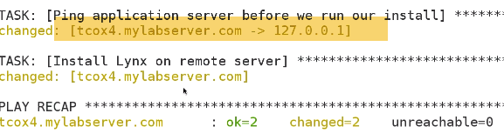

**Changing ping from tcox4 to 127.0.0.1**

Telnet on remote host.. 

If you are delegating all of your external commands not to run on remote hosts group you indicate, it will run those on local hosts..

**-🡪DelegateTo**

**Gives ability to run commands, within our playbook on a host for variety of reasons.**

**EX: Managing cluster of servers, Upgrading one a time.So we might take server running outrunning script that we don’t necessarily copy to large number of servers and run on them.We want to run locally**

**Delagtaions are, when we want to perform actions on single host while refereing other hosts.**

**EX: if we want to do maintenance on number webservers of clusters, and from control server..Running locally we want to take one webserver out of pool and perform Task on it.., and bring webserver back into pool.**

**Inorder to do it, we may have software utlities etc..installed on local server. SO we don’t want to necessarily copy and run them from remote sevrer itself.**

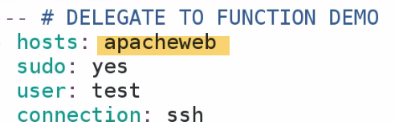

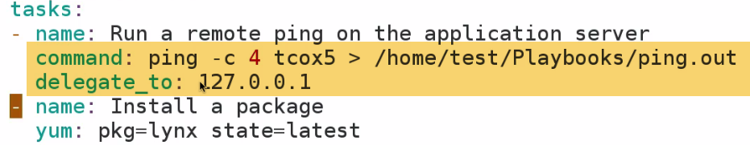

**Without delete_to:ping will actually run of apacheweb, mentioned in hosts.**

**Delegate_to:127.0.0.1-🡪runs locally.**

**If DB server is able to interacct with my command locally, I may want to use git module to update my build.**

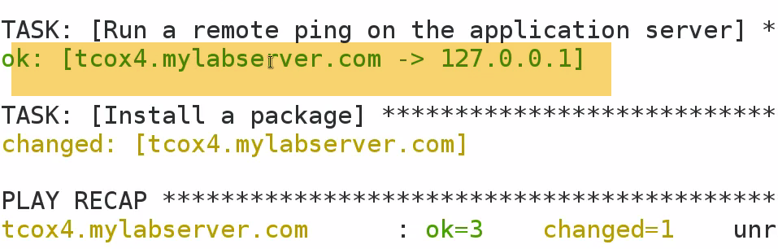

**Redirecting ping from tcox4 to localhost, where we are running playbook from.**



**Ping.out present on localhost.**

**-🡪The 'MySQL_DB' Module:  
Gives ability to create/delete DB, inaddition to create a mysql dump,and import from backend.**

**1.) See if we can login to DB, and check DBs setup** 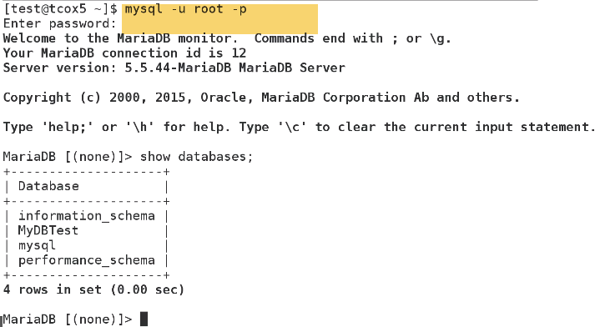

2.) 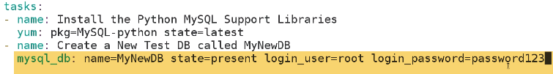

We can use vault to encrypt password that could refer to as variable here…by referring to file.Rather than plain text password

1. verify 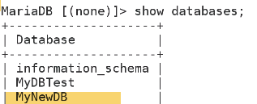
2. Delete: 

mynewDB gone

1. Backup 

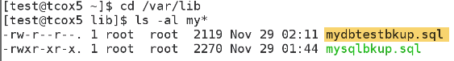 

5.)Restore

State=import, and input target file

Knowledge:  
1.)show databases;

2.)

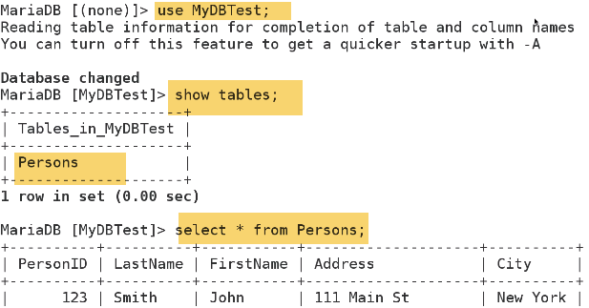

-🡪**'MySQL_User' Module**

Create/maintain on user a/c.

Privileges🡪priv

**Database.table:what kind of priv**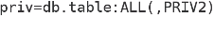-🡪 grant, insert, delete etc

*.* 🡪access all database, all tables, and pretty everything what he wants to do.





**Access denied, because user bob no longer exists**

-🡪The 'Kernel_Blacklist' Module

Allows to blacklist to kernal modules.Reason: We may have a playbook/roles that will install proprietary n/w drivers, third party n/w stacks etc..As a process, we need to blacklist some kernal modules, so that thwy don’t load.

1. Use shell module to create blacklist file ion remote system

Here we have kernal module to do it

1. Anything in /etc/modprobe.d -🡪 is black listed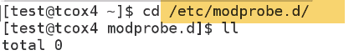
2. 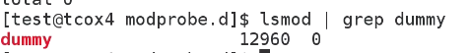

Dummy modules isnt installed. Lets install and blacklist.

1. 

Install dummy module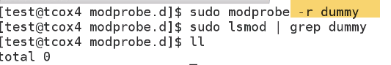

1. Blacklist dummy

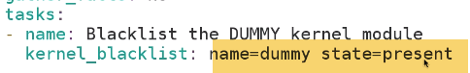

1. On client sys: verify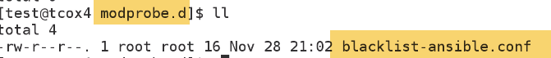

Blacklisted /etc/modprobe.d

**Remove**: 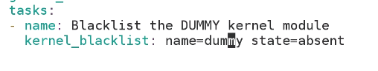

**-🡪Roles - The Directory Structure**

We have seen Include stemenets

Also, how to divide playbook into discrete plays.

**Disadv:**If there is any typo in include ststement, we have to go back and fix it.

With newer version in Ansible-1.4 and above …we have roles

EX: If we create handlers section, we have to include from there…Including that particuylar play in handler secyion can give unconsqequences reulsts.

---New Way of breaking plays into discretee plays,and control within playbook---Roles

**Automation around include directives.Allows us to search paths for reference files.**

**Because, if we set directory structure correctly, and we put name.yml file in certain dir. Then automatically handler/installation etc…What ever you have can be automaticaaly referenced/Included , And run as part of playbook.**

1. **Lets create a top leavel dir. called Roles**

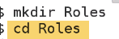

1. **What we are doing…workarea inside Roles**
2. Common dir: Things we do same across all servers

Webserver

Appservers

cachingservers

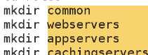

**THIS IS HOW WE ARE GOING TO REFER INDIVIDUAL THINGS**

1. Create a following dir. in all these

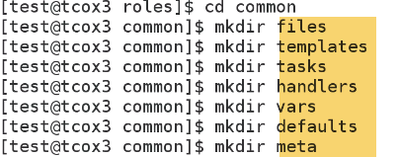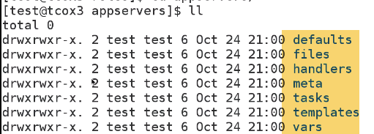

* Files: use locally or transfer to remote servers
* Templates: jinja2 Pyhton formatted template files .

EX: httpd config for hosts or selinx config. or info. we get from gatherfacts.

* Tasks: plays that we done on remote server
* Handlers: like service restarts, generally we call from tasks
* vars:binary val. Key--value
* defaults:Diff. things we do across all servers.
* Meta:metadata.

**-🡪Role Based Tasks**

Roles helps to divide screenplays, and include in master.We can run plays only we want to..based on host we are executing against.

GO to websers now: 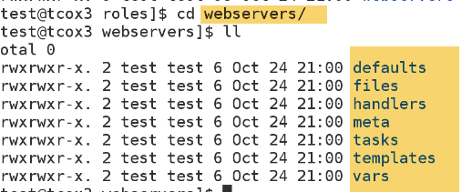

Tasks:

We will create main.yaml.Once we includre role in master playbook.It will scan these dir. and tasks if this main.yaml exists..It will run tasks as part of role.

1. InstALL Apacahe web server, which is handled by tasks main.yaml
2. It is going to call notififcation in handler section, which will restart service, and include variable file as part of role.
3. **Go to top level dir. and create a file webserver.yaml**

Created main.yaml file in each o fthese directories tasks, handlers, vars.

Tasks:

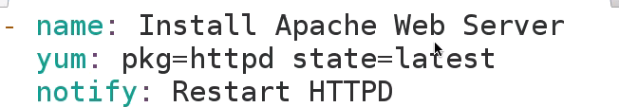

Handelr dir.

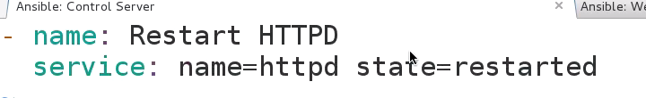

Vars: 

----3.) **Go to top level dir. and create a file webserver.yaml.This is my master playbook for webservers.**

Just give role as webservers:

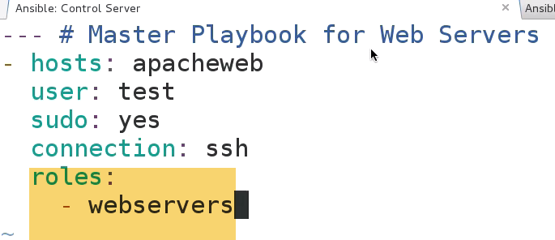

In webservers.yaml, I am running only role I have configured.However, we can still do other things

By running webservers role, It will look for webservers directory, and all dir. underneath it.And it will run everything it have main.yaml file ..And tasks,handlers, vars, meta dir..

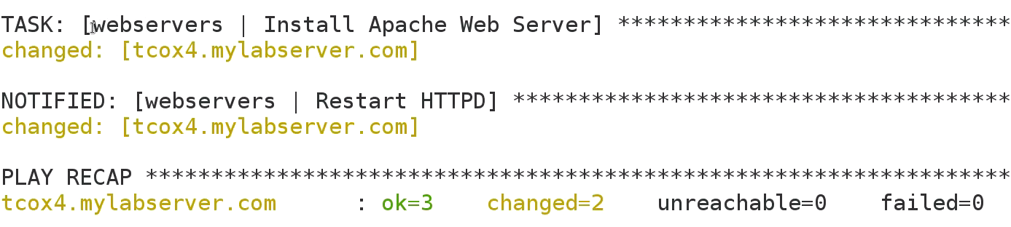

**-🡪Task Order - Pre and Post Tasks**

Breeak complex playbooks into discrete plays that can be included.

* It allows playbooks –that are easy to read
* Include definition of roles we want to run across one or more groups.

If we have main.yaml in vars, tasks, meta etc.., those functions which are defined within playbook or those individual yaml files are included automatically and run, as if we included in that master control file.

In webservers.yaml, I am running only role I have configured.However, we can still do other things

1. Roles will always runs first regardelsss of tasks appears.

So if we want to run tasks before Role, then we need to create pre_tasks.

Unless we use pre_tasks…Roles will be executed first

1. Tasks to run after role.-🡪post_tasks 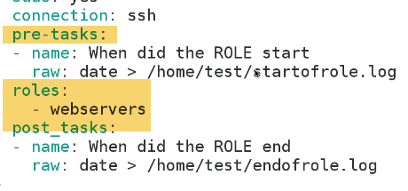

Run some taks, Run role, Then run something after

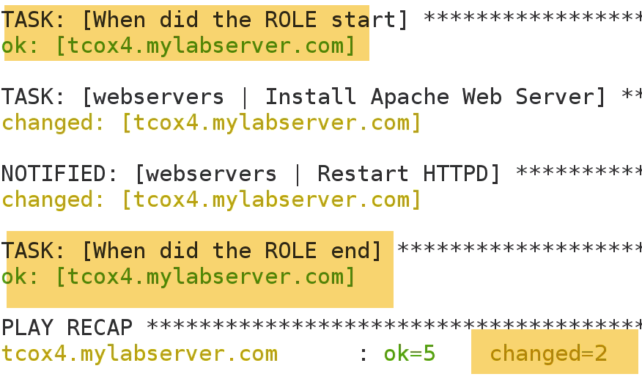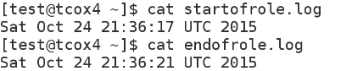🡪 it rook 4 sec for that particular role to go through and run, all of the tasks assosiated with files…Main.yaml created in tasks, var, meta.

**-🡪Roles - Conditional Execution**

1.) tasks🡪

If we excute webserver.yaml, then that role will automatically include any of tasks that are in main.yaml

1.)Let say we have redhat, and executed below tasks-🡪 Completes 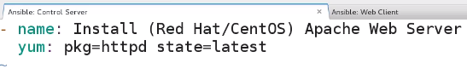

For Ubuntu---------🡪fails

2.)How to install regardless of repo. And Distribution type..?????

Install webserver depending on distribution type

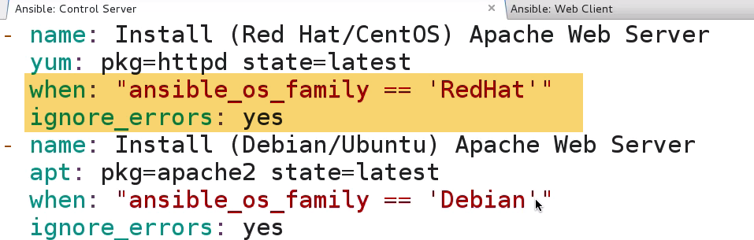

We can also use notify to restart service.

If os is centos-🡪install httpd, Ubuntu🡪apache2

1. No need to change webservers.yaml

For Ubuntu-🡪skipping(redhat)

For redhAt-🡪Skipping Ubuntu

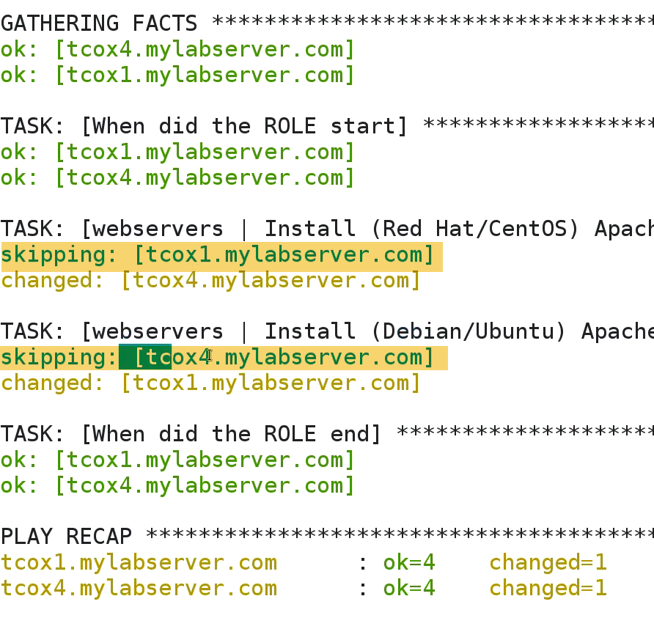

**-🡪Roles - Variable Substitution**

Installed webserver depending on distribution type, based on when condition.

We have to know apache2 is package for ubuntu, and httpd is pkg for centos .How to fix this???

1. Vars-🡪main.yaml

Indicate what those packages names to be.

If package name changes, we have only one file we have to come back to make that change ..Howver how many scripts/playbooks we may have.

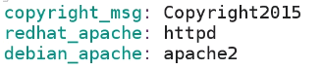

Now that I have created those variables in main.yaml file and automatically included in my role..Then if I goto my tasks dir, and edit my main.yaml file

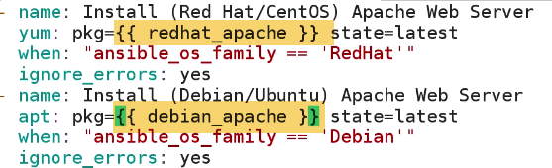

Because I have access to variables, that are included as part of my role.

By definition, they are automatically included.

* I don’t have to pass in path..
* I don’t have to include these as variables in my master playbook .

I can inline, use those values .., as long as it exists in variable file

-🡪We abstracted names of pkgs on distribution basis into variable files that is automatically included.So that we only need to make only a change names in aone particular place if pkg name changes.

You can see how large number of list of pkg names, that we might want to refer to ..can be installed at a time.

**--🡪Roles - Handlers**

* Installing apache based on os type
* Installing package names using variables substitution
* Conditionally notifying particular event, so that it runs as appropriate to service.

Handler🡪main.yaml

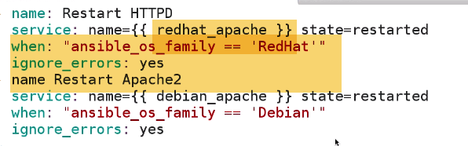

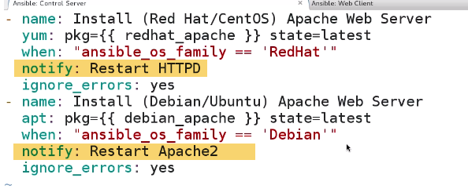

**-🡪Roles - Using Notification**

Debug: gives ability to determine when this particular coammand runs.

**I can issue notification to any handler that I want , at end of any modules except ‘raw modules’, that doeznt take command for notification..Because raw is deisned to a single anad dirty command.**

Using debug module to run arbituary command, taking advantage of our handler behaviour with notifier

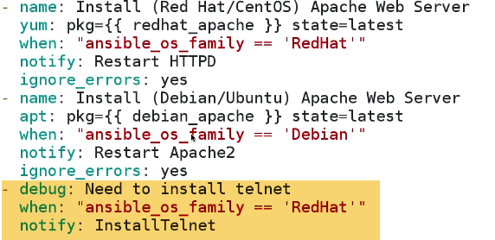 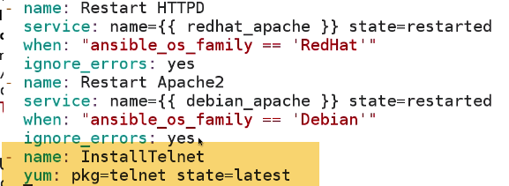

Install telnet happens on only REDHAT/centos

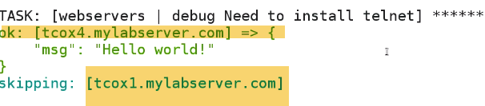

Install on REdhat(tcox4)…Skipps Untun(tcox1)

**-🡪Roles - Configuring Alternate Roles Paths**

**(Configuring ansible to look for roles and default location)**

As organizations begin to share playbooks,And you have defined a control server to run from playbooks from, And have multiple users That want to run multiple playbooks.You have got roles defined in centralized location.

By default, ansible 1.4 or later: We can configure roles path in configuration to check if roles been called with ansible-playbook command is not in current dir. By default, initially ansible-playbook will look for role that you are calling playbook from in current dir. If it is not there.., it will tranverse other dir.

If I run , it will look for particular inclusion of server role within this dir.It will traverse dir. as we expect.

Goto ansible.cfg file: 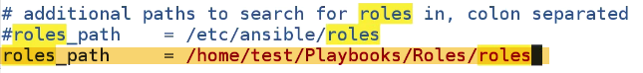

1. Copy webservers.yml to a different location.This would fail because webservers roles are not defined in the path.--------BUT NOT



1. Since we want to restart ansible, as it is daemon related executable.

3.)



It should search roles path to determine, where that particulat roles exists

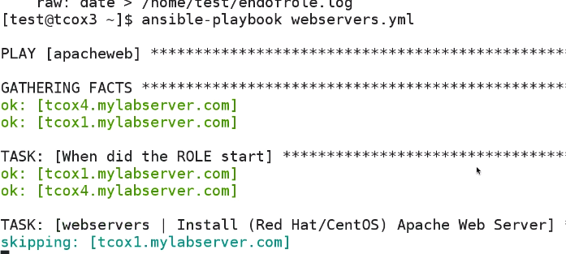

Rather than failing, webservers.yaml is going through and running expected tasks …As defined in roles.

In Shared wnv. We have multiple people that may be sharing playbooks, that needs to inherit functionality in roles we defined in system level.

Not to mention, appropriate server we setup, with SSH key exchnage etc ..Or developing own playbooks that just needs to inherit characcteristics from roles.., that are clearly defined, and stored in common location.

Ex: github repo..for example.

This gives ability to just configure controls server to be used by multiple users and pointing to default(which is my local dir), or a centralized location where my base roles are installed.And then I can include in any of my ansible workbooks or playbooks.

**-🡪Roles - Conditional Include Statements**

Different ways of doing things, based on facts we gather called ansible_os_family.

It’s a way of determining what path we want to execute certain commands, based on value..Which tells it is Centos/Ubuntu.

Now, that we have differentaited on system within hanlders or tasks..,We can gonna see how we are doing at Role level.

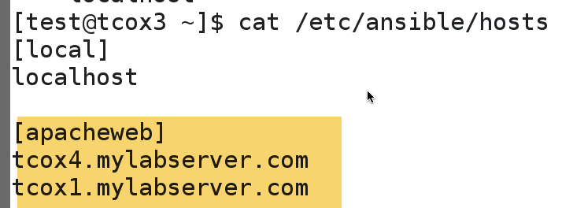

We have Ubuntu and Centos…Hence crux of problem.

We are handling different distributions of problems., at a task or handler level.

When we say install apache, we are writing 2 different commands..based on value, that we are going to run against.

**What can we dooo????Make my roles more granular..**

If we have master control file, that include any role, if it is in exact dir., that we execute playbook from within..It will search for dir. for Roles we included in.

1. Lets make dir. redhat_websers, debian_websers

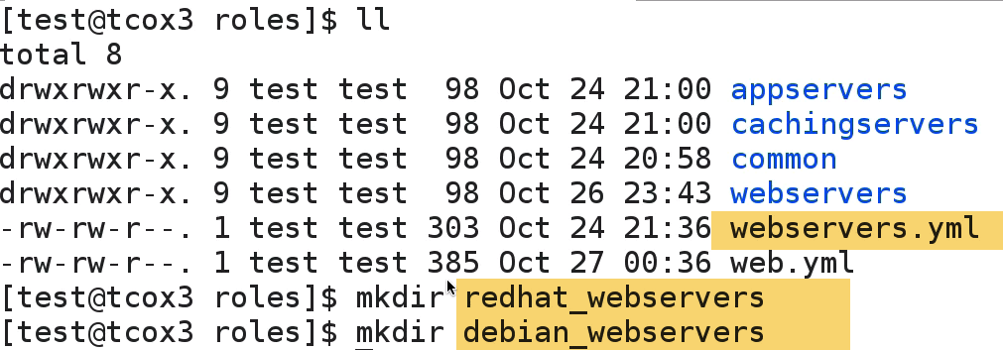

1. Copy webservers file into redhat_webservers

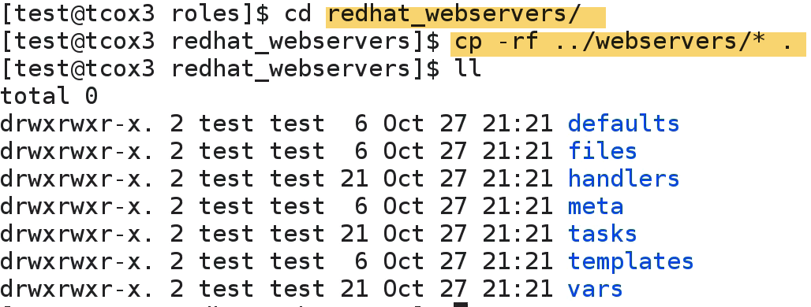

**-🡪Galaxy Introduction and Usage**

Reuse from our org. or other places(community developed)

🡪 Hosted on github

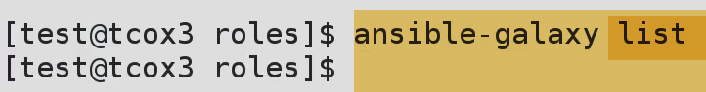-🡪no roles here

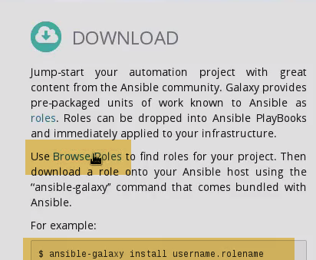

1.) 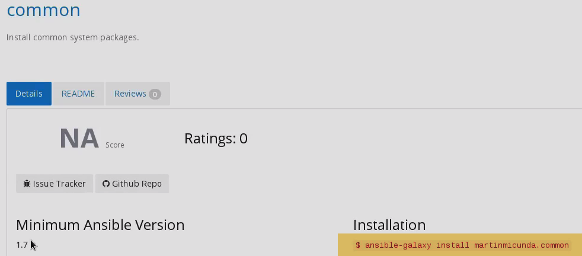

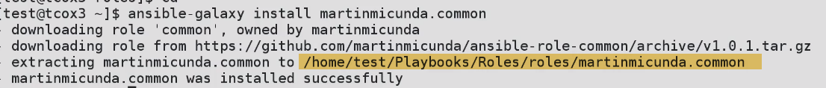

1.)Defaults

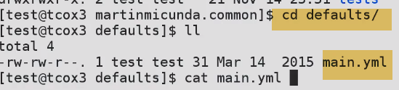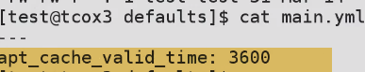

2.)meta: give info. of author, desc, license etc

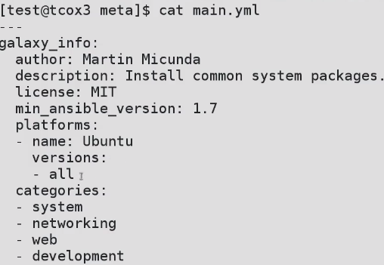

3.)tasks🡪actual file

4.) README.md🡪 how to use it(help)

**-🡪Ansible 2.0 - Installation**

2.0 🡪Installing, not from repo…From source(github here).

On CentOS7:

1. Create test user: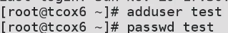
2. Visudo 🡪 add to sudoers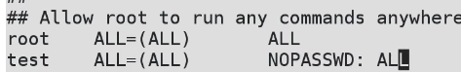
3. Create ssh-id, so that we can exchange with others
4. Test



1. Ansible-2.0 branch 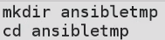

---apple repo(install ansible from apple repo)

---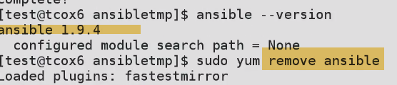

No Anisble 2.0 from epel.So install from git--source



Make; 

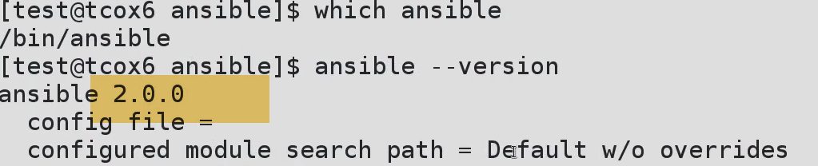

We have no config. file

**/etc/ansible 🡪 not created durint make proces.**

**There is a directory, called examples.This is dir. which should exist in /etc/ansible**

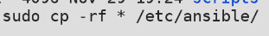

**-🡪Ansible 2.0 - Playbooks User Privilege Escalation Changes**

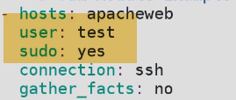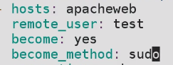

**-**🡪**Ansible 2.0 - Modules The 'Find' Module**

**Know: location, creation of dir.,attributes of file, size of file, last time it was updated** 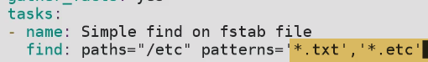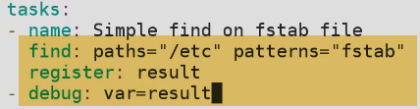



**-🡪Ansible 2.0 - Modules The 'Package' Module**

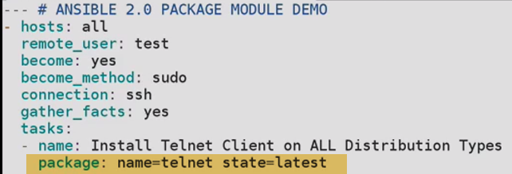

**Install pkg on all distributions(redhat,debian) etc..**

**-🡪Ansible 2.0 - Roles User Privilege Escalation Changes**

**Let’s take at webservers roles.**

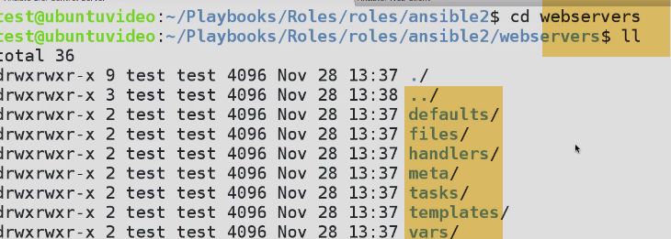

**We are going to change:**

1. **Tasks->main.yaml**

(install packages based on redhat/debian)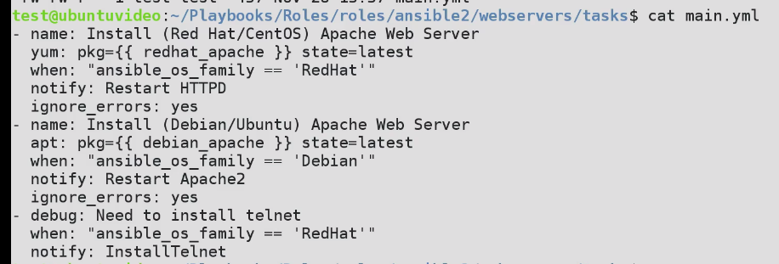

2.)webservers.yaml

Calls roles depending on ansible_family returns for role of server, that are defined in hosts.

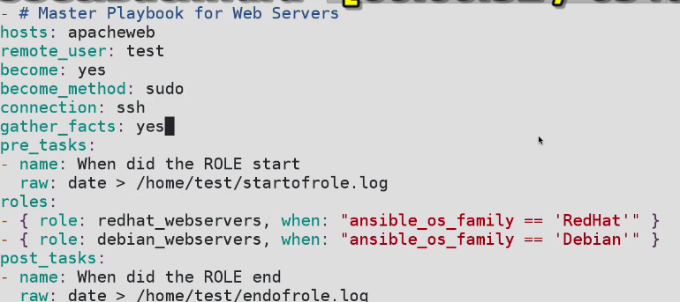

**-**🡪**Ansible 2.0 - Roles The 'Find' Module**

Use find module within roles

We can specify hosts like an array:



a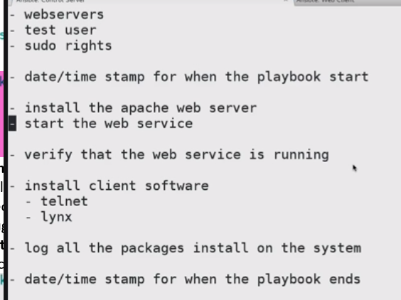--🡪Webserver.txt

**-**🡪**59-512-1 - The 'Setup' Module**

This module is automatically called by playbooks to **gather useful variables about remote hosts that can be used in playbooks.**

**Most common facts available in machines.**

It will bring whole bunch of facts…Difficult to read.SO doing on 1 client m/c only

-🡪 all clients and all env.. tough to read at a time



**---Let’s say I want to install apache. I want to know about distribution and version available across all servers configured in hosts file.**

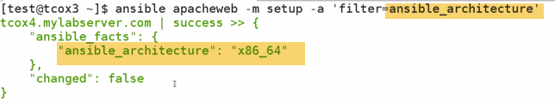

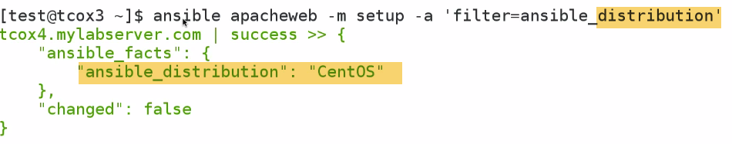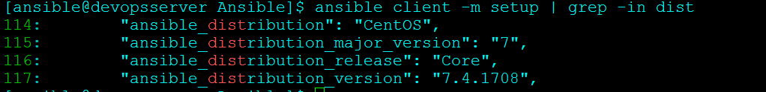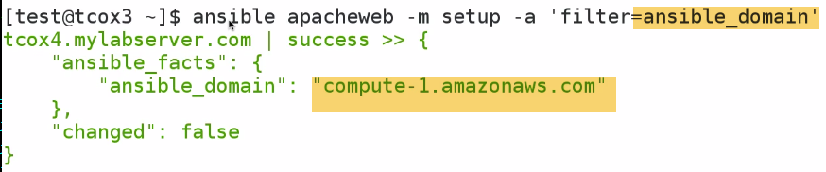

It is because Linux academy servers running on aws..

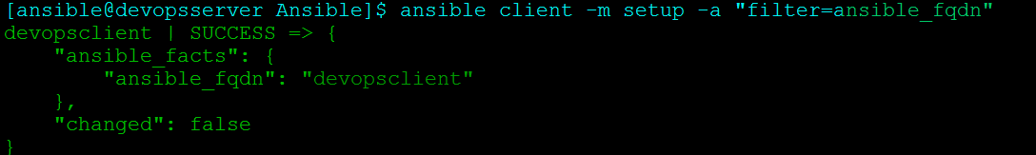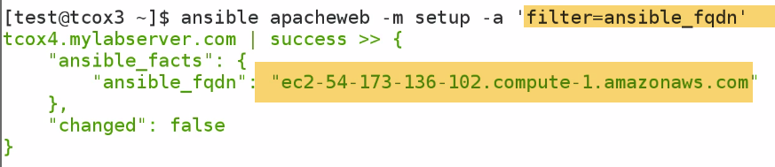

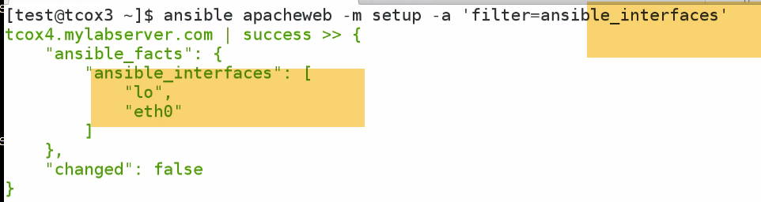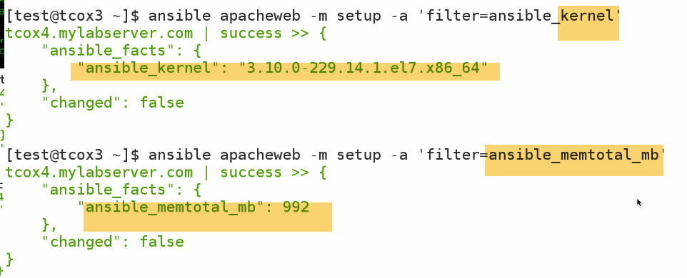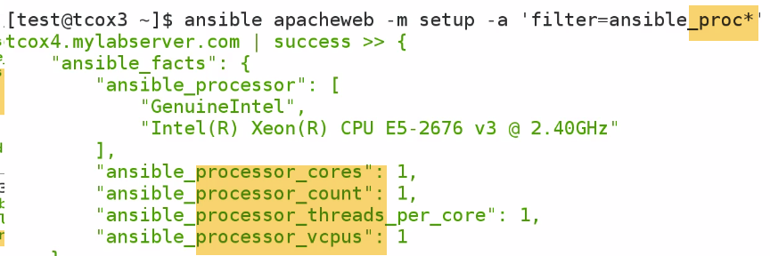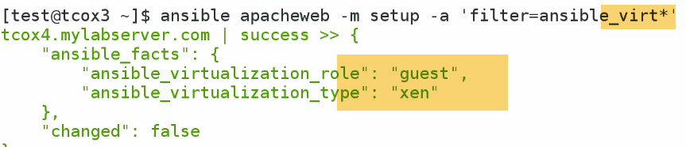

Note: this info. Are gathered by python.

FILE, COPY,COMMAND modules allows us to do things with files or dir..

**-🡪59-512-2 - The 'File' Module**

Sets attributes of files, symlinks, and directories, or removes files/symlinks/directories. Many other modules

support the same options as the `file' module - including [copy], [template], and [assemble].

**---Interact with File system. Pull info about fstab**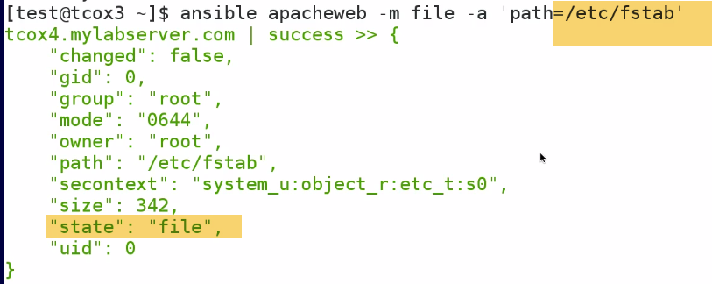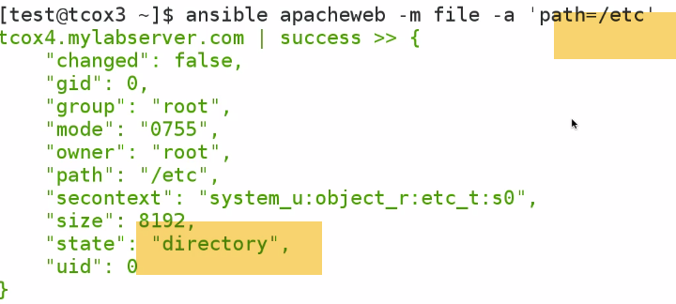

---Change ownership of file, copy file, setup new dir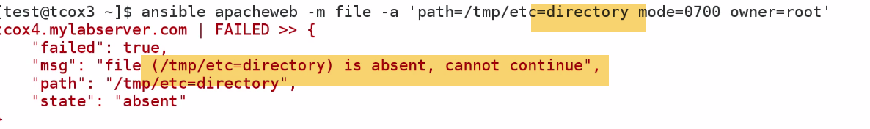

Directort /tmp/etc doesn’t exist..So we have to use state=directory (create a directory if it doesn't exist) 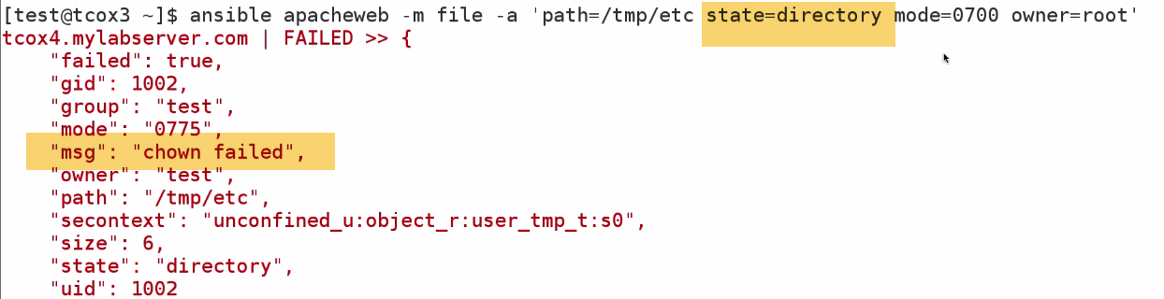

Now again, chown failed…because we didn’t execute as sudo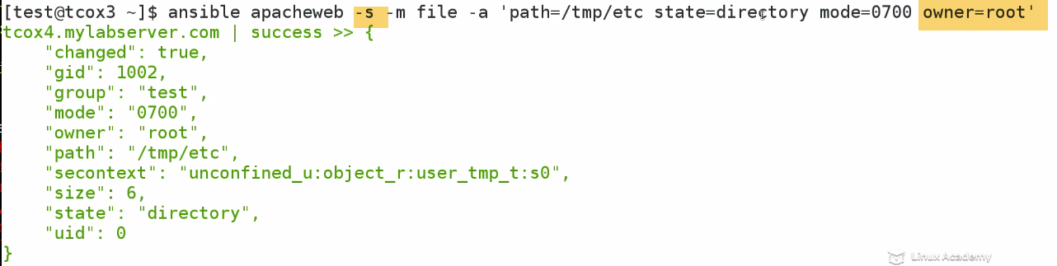

**COPY Module:**

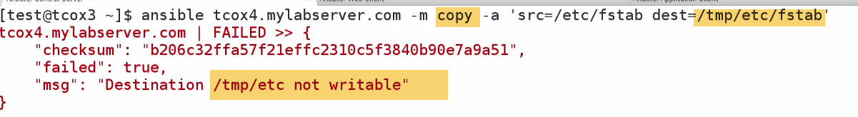

/tmp/etc/---Owned by root here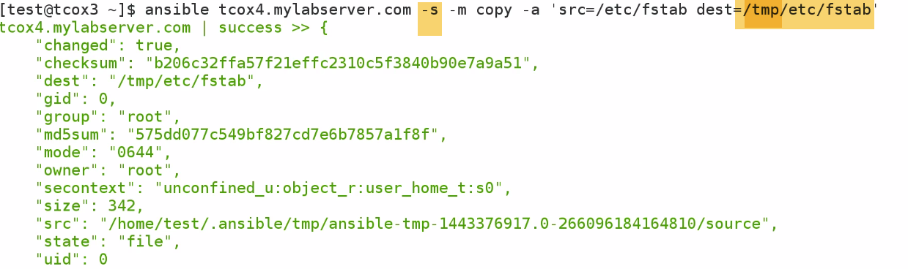

**COMMAND:**







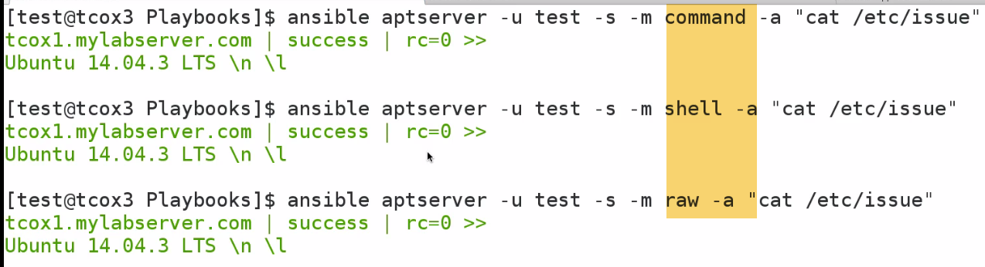

All these 3 giving same o/p. All goes to remote server, executing arbitrary command..

**Shell and command adv.:** There are specific functions that allows shell and command to register o/p to pass in particular directory...

**PAUSE**

It stops execution of playbook either a key is pressed for certain amount of time.

Generally we provide when a user need confirmation to continue..

Ex: 1.)We want to Deploy a webserver... but we want user to test webserver, before we continue on rest of playbook that do other things.

2.) We can use pause module, So that we can Pause without killing or running multiple jobs which needs user input.

3.) We can use Prompt and get information about a variable

It is never used a much as wait-for module, because it is less interactive method of pausing playbook.

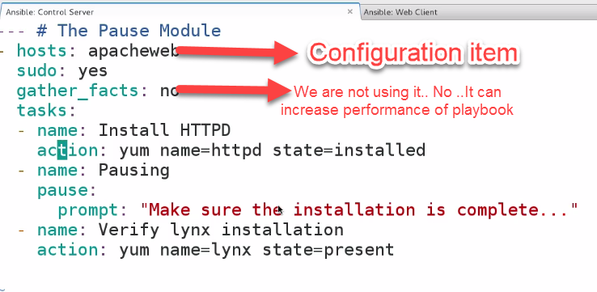 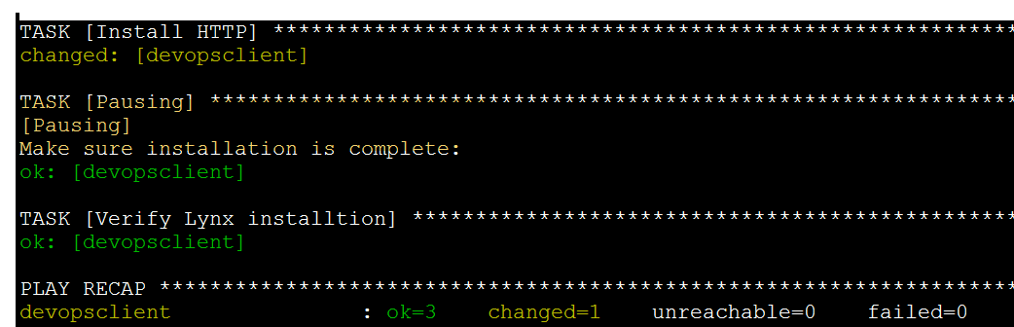

Pause…

Also, lynx already installed... So change=1 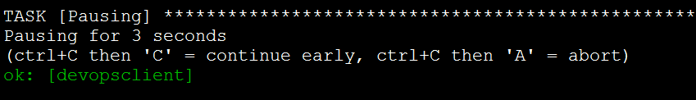

**WAIT_FOR**

--Wait for some dependency like file or restore database or port to be listening.

Will not continue playbook until port accepts remote connection.

Now, Install tomcat, which by default listens on port 8080 once started. Use playbook Pause and wait until we go over server we deploy tomcat, start up and verify listening on port 8080

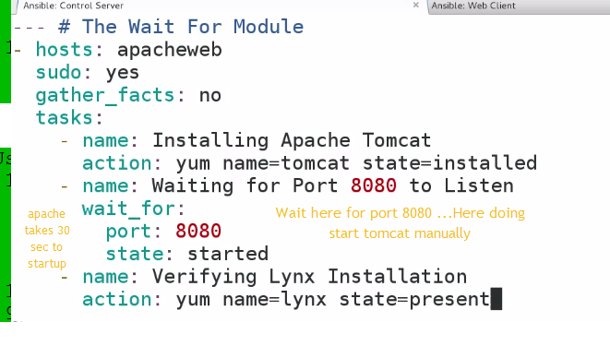

Apache takes 30 sec to startup like:

Waiting for DB to connect

Wait for large ends memory

Caching before to start

- state

either `present', `started', or `stopped', `absent', or `drained'

**When checking a port `started' will ensure the port is open,** `stopped' will check that it is closed, `drained' will check for active connections

When checking for a file or a search string `present' or `started' will ensure that the file or string is

present before continuing, `absent' will check that file is absent or removed

(Choices: present, started, stopped, absent, drained)[Default: started]

WAIT_FOR is common methods for waiting for an event to take place in playbook

**'Yum' Module**

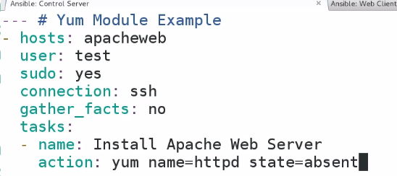

Used for package manipulation of remote clients

Query, remove, install pkgs

State=present or installed—any one

Remove🡪absent

Update🡪latest

 -🡪yum upgrade

- name: install the latest version of Apache from the testing repo

yum:

name: httpd

enablerepo: testing

state: present

**- update_cache**

Force yum to check if cache is out of date and redownload if needed. Has an effect only if state is

`present' or `latest'.

(Choices: yes, no)[Default: no]

**APT MODULE**

**---Setup Ubuntu server on hosts file** 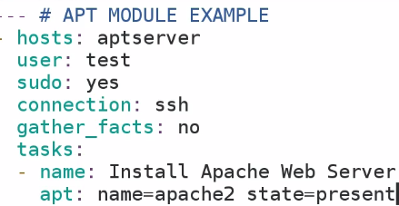

Upgrade🡪

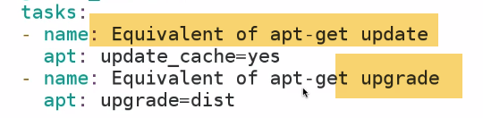

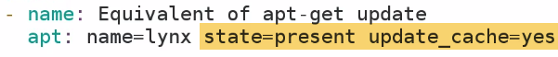

---Install links and do sudo apt-get update

SERVICE MODULES

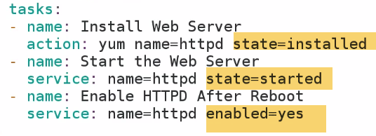

Enable/Disable services for entire environment. If I have a host group environment DEV.

I make change for one configuration; can be applied to all in DEV env...

**COPY MODULE**

COPY files from local to remote including setting of user, group ownership, R/W

Backup files

**1.)**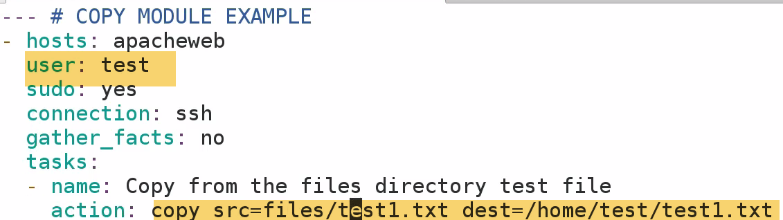

**One thing need to worry is permissions is on root**

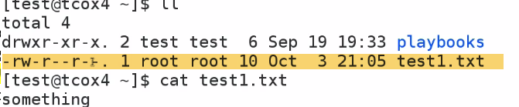

**2.)**

 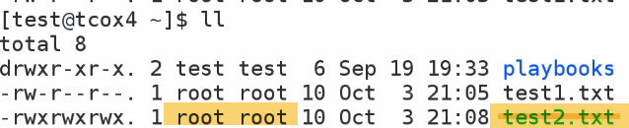

1. 



-🡪What if we want to copy files and don’t want to loose changes

On Client m/c create text4.txt

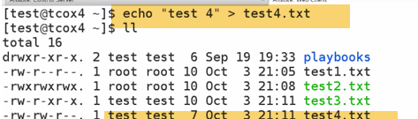 

Make backup of files, that we might accidentally overwrite if exists in destination system 

**Get backup file with file.Timestamp**

Particular useful in builds, checking code from github and copying config. Files when changed in dir inside group f services.

**Ex: When changed apache vhost config. for particular website and have 5 webservers in cluster..We can use single copy command and copy that to all individual servers. Then, use service module to restart service on all webservers**

**-🡪 'Command' Module**

Fills in.., when Used to run commands when modules doesn’t exist by using builtin shell over ssh.

We can used to install modules, log files etc..

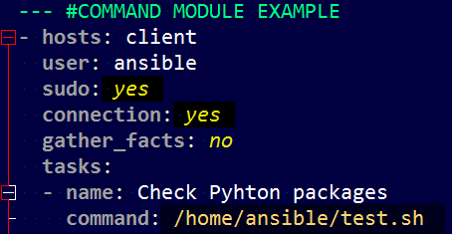 

Here we are sying: TO run command from a particular directoery..

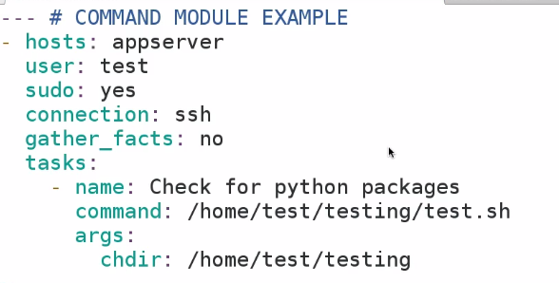

- chdir

**cd into this directory before running the command**

**---CRON MODULE:**

If not given will run every day of month

Every week of month @1 am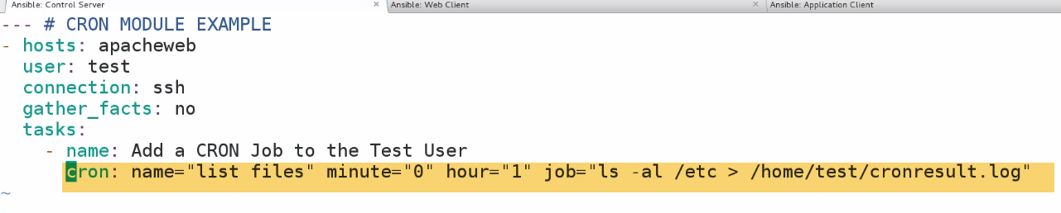

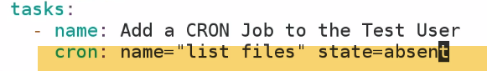

DB backup, user refreshes, permissions

-🡪**Debug MODULE**

**Troubleshoot, what values set to variables..**

1.)

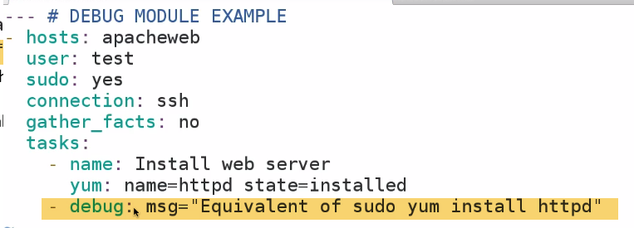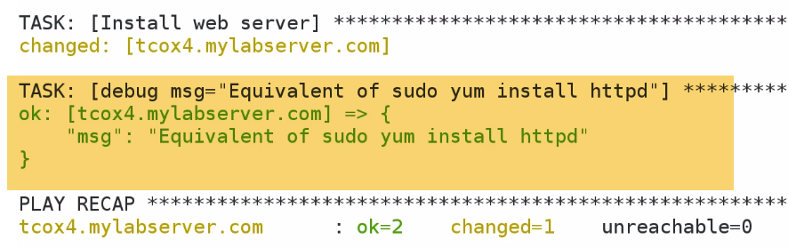

It will show what tasks is done in JSAON format

2.) How long system is UP??

/usr/bin/uptime-🡪Wouldn’t seen on screen even if succesfully run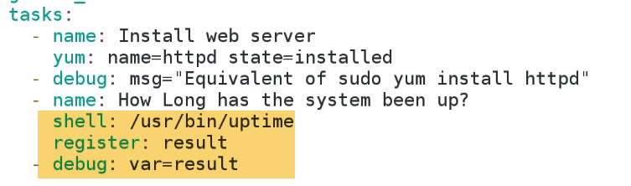

**-🡪FETCH MODULE**

This module works like [copy], but in reverse. It is used for fetching files from remote machines and storing them

locally in a file tree, organized by hostname. **Note that this module is written to transfer log files that might**

**not be present, so a missing remote file won't be an error unless fail_on_missing is set to 'yes'.** 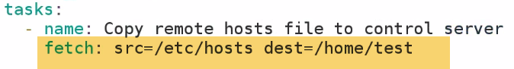

It will create a directory devopsclinet folder in /home/test user

And then create /etc/hosts file in it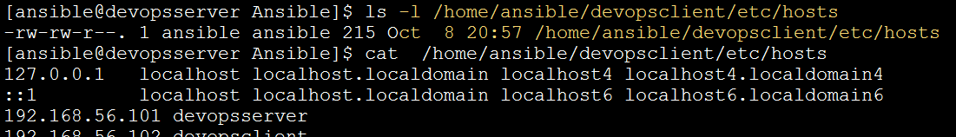

2.)



**Noe: Gather_facts=yes: Because I’m using ansible_hostname system variable.**

**If hostname is changed since last time, facts will be gathered., it pulls correct hostname**



**It created a prefix-hostname file**

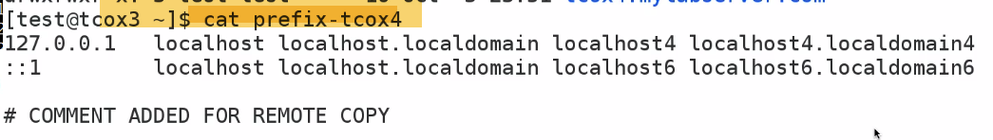

**By indicating name in direct path and flat=yes**

**Take that hosts file, name it locally prefix-hostname.That allows to bypass automatic creation of path ---(Hostname, and remote directory)..So that we could have single file prefix-hostname.**

**3.) With** 

**It will gather all hosts file**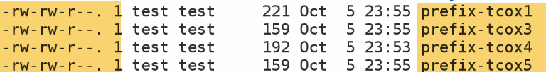

**On all environments..**

**-🡪USER MODULE**

* We want to create user, after we installed apache web server.
* We want twant to set to particular owner for apache service
* We want to run somethiing as particular user

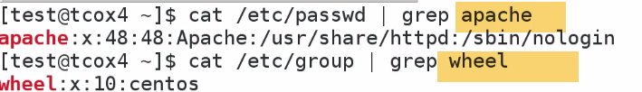

1. 

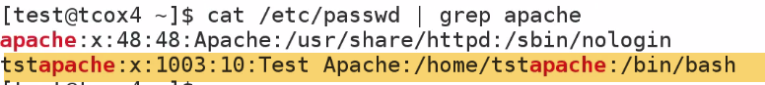

1. 
2. 

Account to expire at certain date.

Set SSH keys for particular user

We have setup an application, and want to be run/owned by particular user

/var/www/html ---owned by user

**-🡪AT MODULE**

Execute at some time in future, but not exist perpectually.

Run, Forget it later.

- command: A command to be executed in the future.. [Default: None]

= count: The count of units in the future to execute the command or script file.

= units: The type of units in the future to execute the command or script file.

(Choices: minutes, hours, days, weeks)

EXAMPLES:

# Schedule a **command to execute in 20 minutes** as root.

command: "ls -d / > /dev/null"

count: 20

units: minutes

1.) 

**1 min. from now, because we have indicated conunt=1**

**2.)**

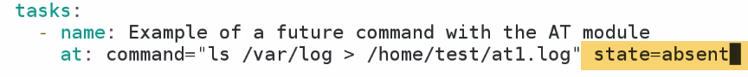 

**-🡪DNF MODULE**

**Specific to redhat/centos>= 7…Minimal not installed.**

**Replace yum module**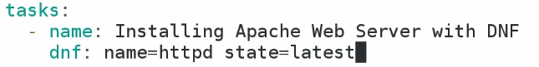

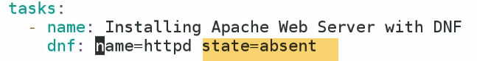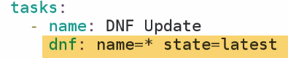

**-🡪Install Group packages**

**-🡪APACHE2 MODULE**

**Ability to enable/disable specific module in Apache web server.**

1. **On 14.04 Ubuntu node, with Apache installed, and running**



1. 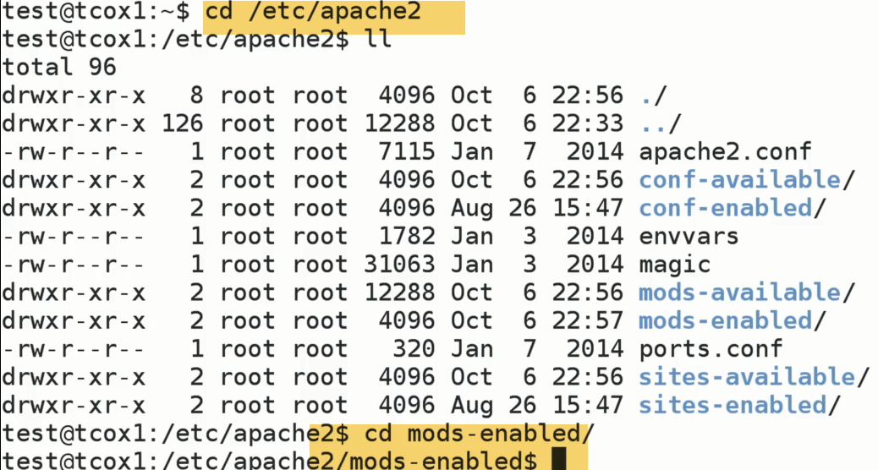

**Under /etc/apache2 there is mods-enabled directory**

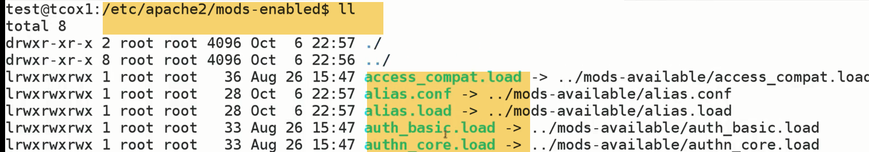

**Shows list on modules available and linked**

1. **We re going to pick alias here..**

**Alias reads from mods-available directory, so that it knows how to load into memory for supporting Apache web server.**

**Note: Apache2 Module applicable for Ubuntu/Debian based systems.Because module mgmt for Centos is either within httpd file config. directly or externalized if we change those values.**

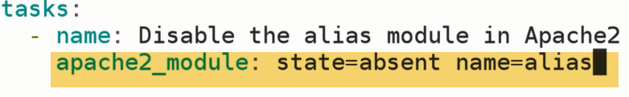

No need to specify fully qualified name.Ansible is smart enough

1. ansibleplyabook ….



Alias modules is not seen now.

**-🡪'SetFact' Module**

When we don’t want system facts in playbook, we turn them off to save time.

Howover we want to set facts that lasts b/w playbook for particular hosts or group of hosts.

**Variables set in playbook only persist for playbook thaey are member of.However, if we set fact for particylaar host with in playbook, then particular fact will be applied to subsiquent playbook, Until fact is set to somethin else.That fact is simply a variable.**

**Setting fact gathered through facts from remote system from within playbook.We are going to set facts to something else.But going to set a fact that persist across playbooks.**

**Stat Module**

Retrieves facts for a file similar to the linux/unix 'stat' command.

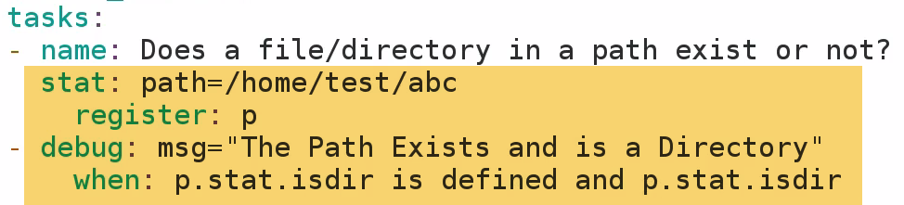



Skipping because dir. Doesn’t exist and failed test..

2.) 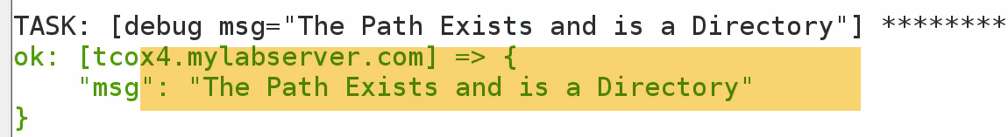

3.)We can see if that is a link

.stat.islink

.stat.isfile

If we are deploying a piece of software, and it is generating a errr log to a file to particular location on remote location.

Based on that info, we may redploy application, if we find particular bug..Because log file exists indictaes s/w to be updated.

We can test if file/dir exists and conditionally executes other parts of playbook.Again, if we look at aprticular modules.

This module checks for existence of files and dir..and conditionally executes other complex modules in playbook.

So if we want to use stat command, rather than pulling back info. Using shell Module..We can use STAT command

**-🡪 'Script' Module**

Simply execute script on remote host/hosts

**We can use COPY module to copy file form Control server to client server, and then we can use SHELL module to run remotely. 2 steps:**

**But fortunately, One module that combines both functionality—SCRIPT module**

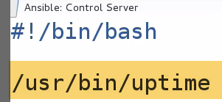

**Script.yaml takes local script system_uptime.sh and run on remote system.**

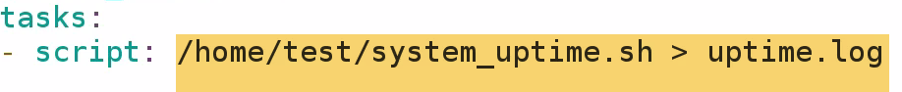

**Verify uptime.log created**

**# Run a script that creates a file, but only if the file is not yet created**



**- script: /some/local/create_file.sh --some-arguments 1234**

**args:**

**creates: /the/created/file.txt**

**In this case, Uptime.log file alreasy created…So it wont create again**

**-🡪 SHELL Module**

Gives ability to execute remotely arbituary commands on remote server.

Simailr to script/command module..with few diff.

We cant execute local command remotely.This Shell command will execute scripts that already exist remotely.

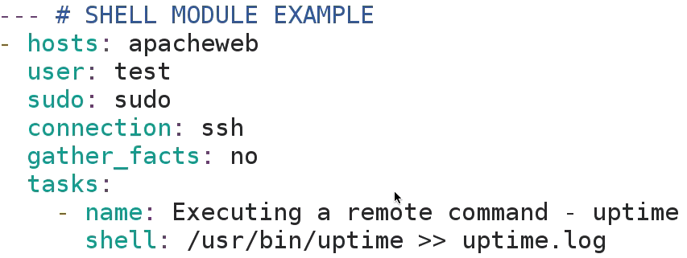

---Change working dir. to sub-directory logs, and runs when logs doesn’t exist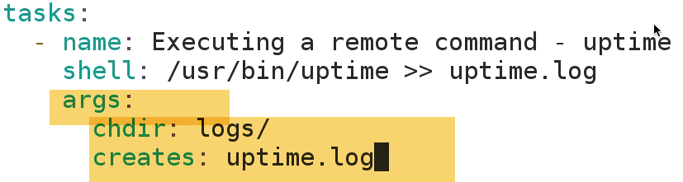 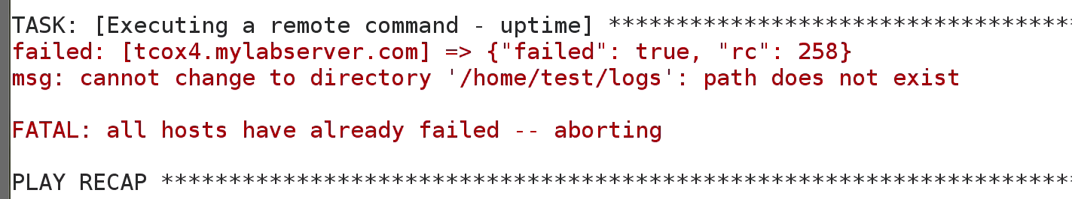  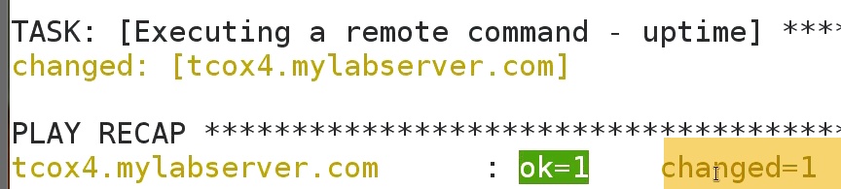

-🡪re-run 

Because file exists already,wont run again.

File unchanged.

-🡪Remove uptime.log and try again..

Changes updated

**-🡪 SELINUX Module**

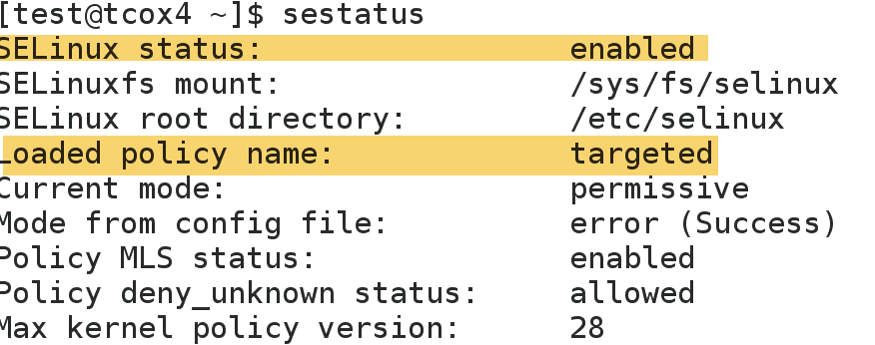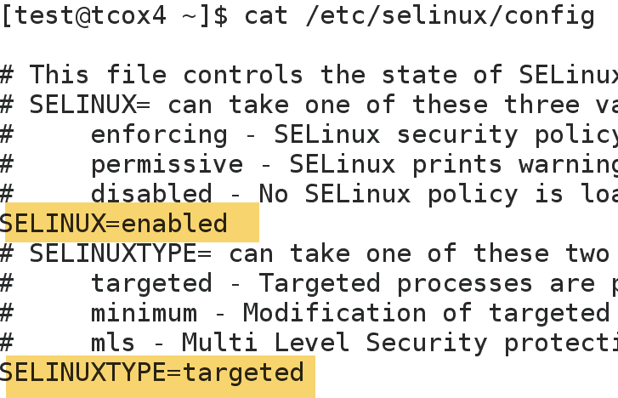

1. 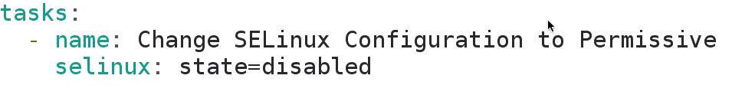
2. 
3. Check on Client:

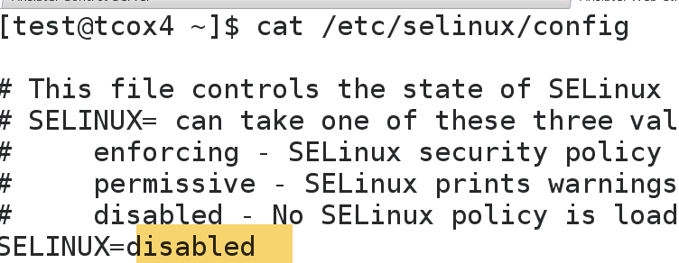

Also: 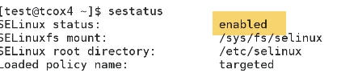

Sestatus is still enabled, because I changed only configuration.

-🡪Reboot is required.

**---**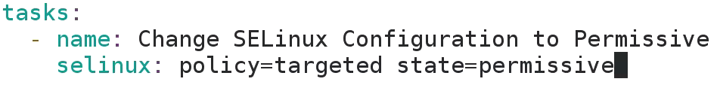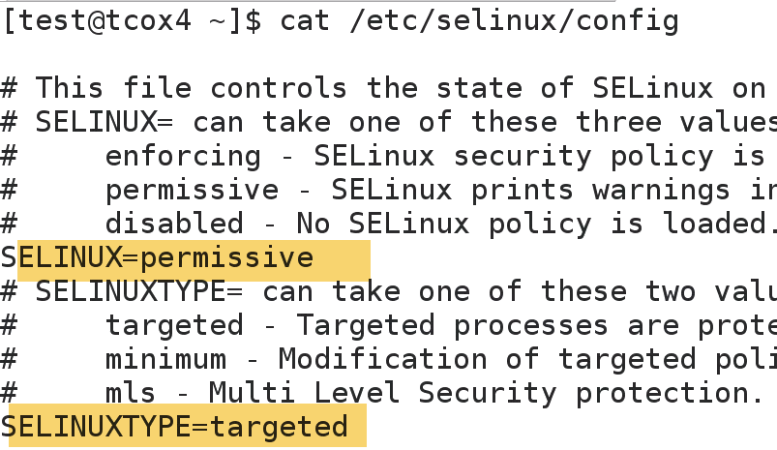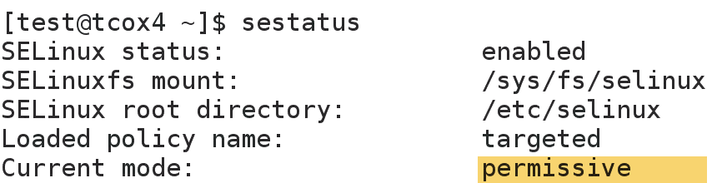

**-🡪SEBoolean MODULE**

Selinux module gives control over state, whether it is enforcing, enbaled, permissive.

SEBoolen🡪values y/n or 1/0

We can get various values from selinux using:

**--getsebook**

**--setsebool**

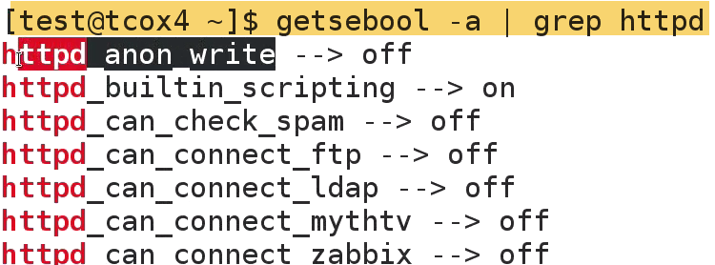

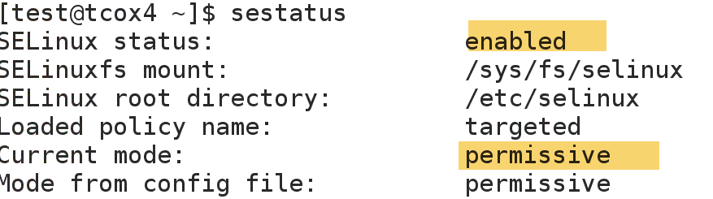

1.)



survive on reboot or session based???

Persistent=no(by default---per session)

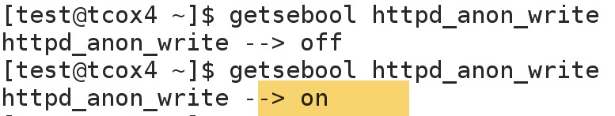

**-🡪RAW MODULE**

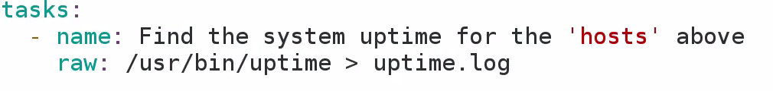 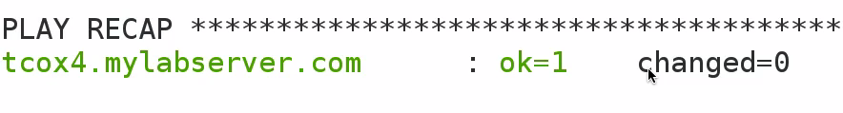

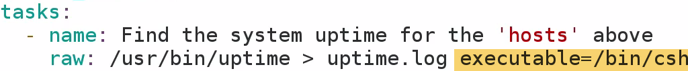

**-🡪PING MODULE**

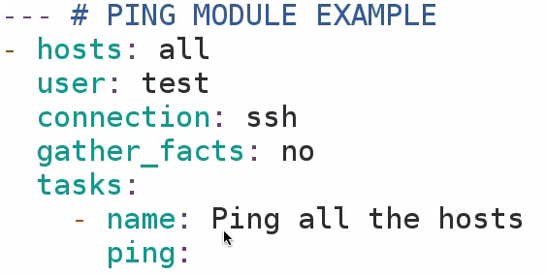

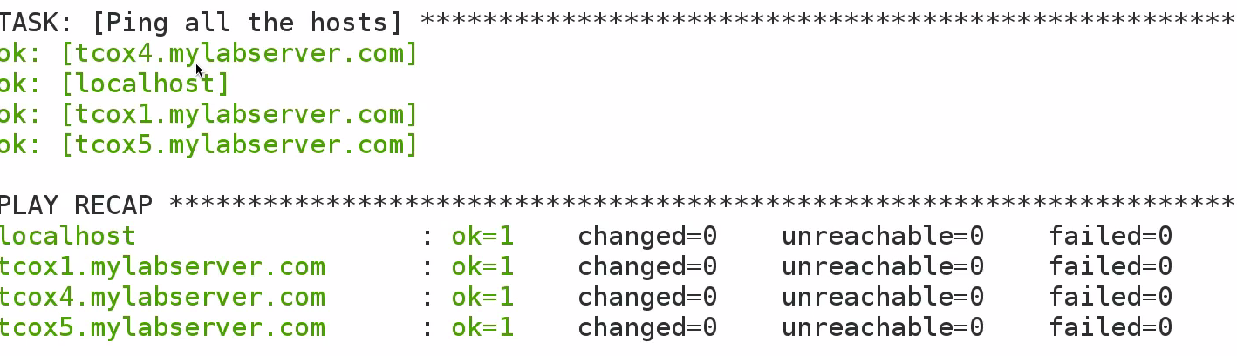

**-🡪Unarchive MODULE**

Unarchieve tar, gzip on remote system.

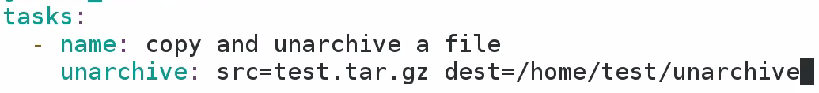

---Copy file to remote server

---UNArchieve file

--Unarachieve doesn’t tar/archieve ..We can do with RAW, SHELL commands.

Suppose I have checkedout source code form particular website that needs to be deployed in large number.

Rather than, run a command that individually checksout source across all my webservers..,I may run out script that checkout version that I want,Tar and compress it..then unarchieve at approprite directory on all dozen servers that I want to deploy code to.

**'HTPasswd' Module**

**As we configure websites especially for those needed users, admins grant specific permissions,for deploying websites**

Compimentary—Not extermely useful.

In installation of website, we may want to add user authentication to existing webserver. 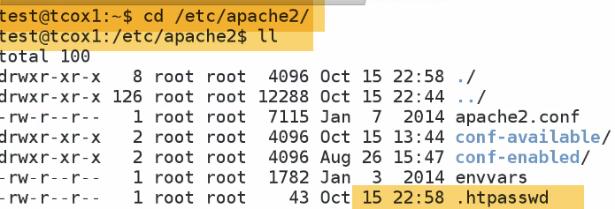



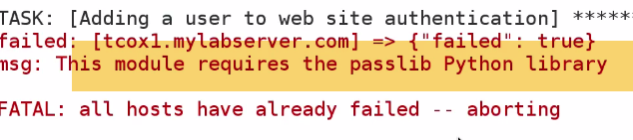****

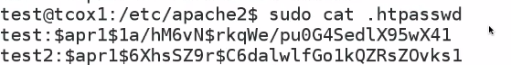

**Now you can see test2 is added**

**Remove user2**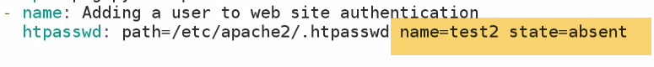****

**GETURL Module**

How to download file using module from website

Basic https authentication

Custom headers

Force checksums

**Module is usieful interms of downloading remote files**

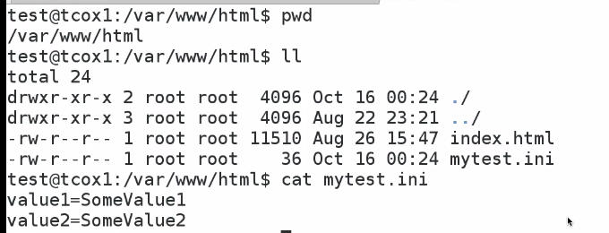

**Now, we will Download mytest.ini file**



**Webserver address Ask for password, if we don’t have local httpd file**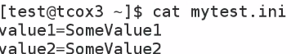

**GROUP Module**

USER MODULE: Manage user a/c on any of our client systems, as well as defining UID, groups user belongs etc..

As compliementary, same thing can be done using Group module.It is simplistic than USER.

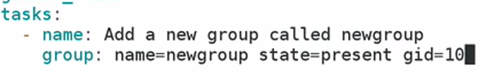

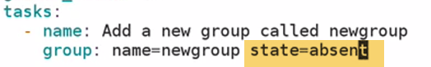

**-🡪MAIL MODULE**

Gives ability to send emails externally say: hotmail, gmail to a send mail to number of users from control server, So we can send mail as completed.

Now: we will be sending mail from remote machine rather than asnible conteoller node.

Reason is: if we run through , and deployed a webserver.We gone through entire configuration and playbook is just about to finish, and nor more errors. We want to notify developers about webserevrs have been succesfully provisioned…Giving hostname of particular server.so that they know what it is and able to login to it.

If I want to send an email using remote m/c..Lets say it to test users.

-🡪Send mail already setup of ubuntu system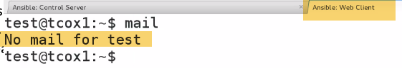---No mail for test user.

🡪 gather_facts=yes

Part of mail message is going to contain a variable that is picked up in remote fact gathering for Ansible hostname of remote system, that we are mailing to/from.

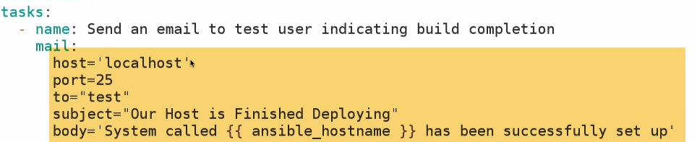

-host: localhost: because it is going to run on same server.Sending mail from remote host to ourselves on localhost.

Smtp port 25

To🡪 local user( test).We can specify email id: [hari@gmail.com](mailto:hari@gmail.com)

Body: {{……}🡪 this is reason why we didn’t turned off facts

**-🡪FILESYSTEM MODULE**

Prepare FS for us to mount module

Here: we have additional disk, that currenty is not formatted

Lets prepare FS by partitioning it. 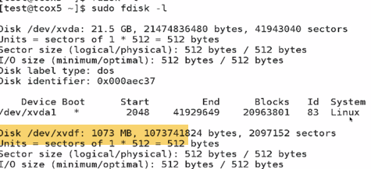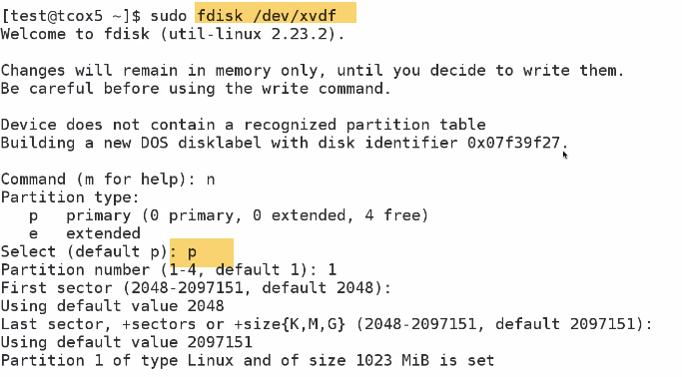

**-🡪**

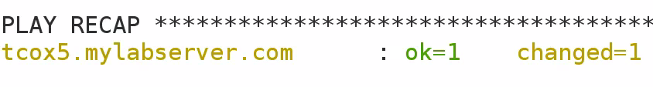

**For testing: Creating a mount point:**

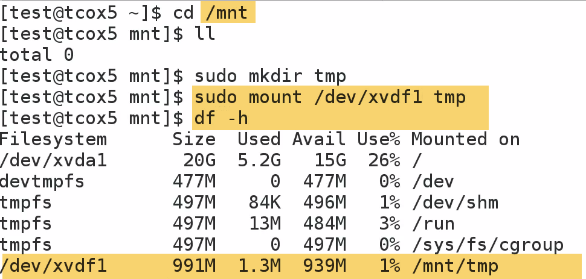

Take multiple disk and build exactly FS that you need.

I could create FS and mount on /vara/lib..So that mysql resides on this dir..

**-🡪 'Mount' MODULE**

Allows direct interaction witth underlying FS. 

Present: mount point and xvdf are present

**-🡪Notify MODULE**

Handlers consists of 2 sections.

1. Ability to notify, when something happens
2. Effecively execute other set of tasks.

when something happens,other section of code Effecively execute other set of tasks.Although it is not task for sake it’s own handler –kind of equivalent in programatic language of event handler.

something happens🡪something is notified that thing happened🡪something happens as a result.

If notification isn’t sent, action doenst takes place then handler wont even execute that paticular action.

1. we want to install apache, and restart service.

If we install Apache …Apache is likely going to start service automatically.We may want to make sure service is started by sending notification..that application is installed and notify service is restarted..

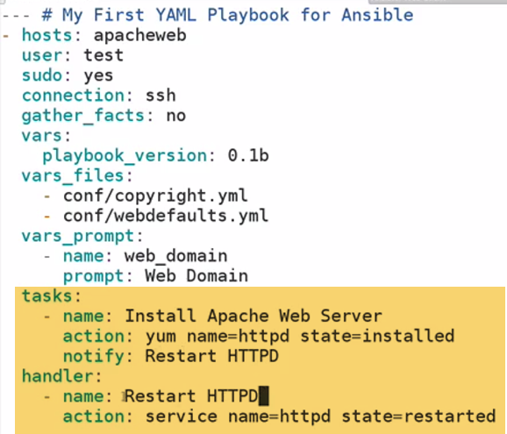

Task: Use Yum modeule to install apache..Then Notification(When I am done, do something)

Add notification:restart httpd

Now, creating handler…Handle that event and Take action on it..

**This will Restart service whenever handler is called by notifier that takes place in our tasks.**

We also need to set service enabled/disabled

**Note: Notification should match Name of handler**

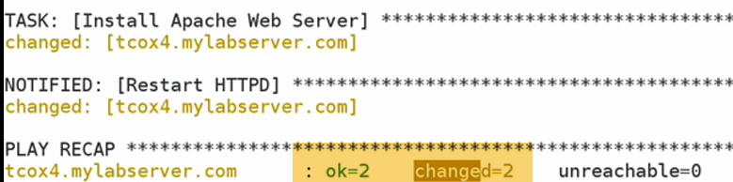

1. **Now, installation doesn’t have a change/done.It will not have notification event now** 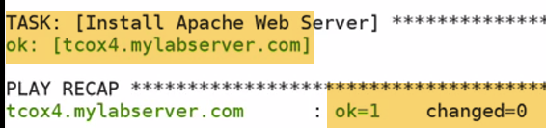

**Becareful with notification: Don’t configure anything as a handler, that is required to run on playbook because you don’t know necesaarily if that particular task is going to run scuccessfully.**

**In this case..It ran succesfully but it didn’t make any change.Change doesn’t need to made when notification event is not thrown**

**-🡪AptRepo MODULE**

Add repository to our sources list distribution(apt-get/aptitude).

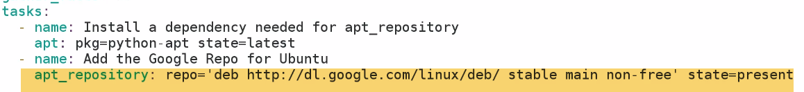

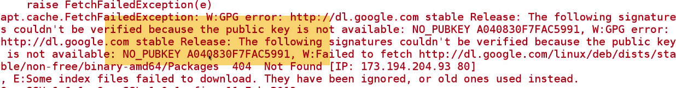

**Failed : we have not installed public key.**

**We use apt-key package to install repo.Next module we will add apt-key**

**-🡪'AptKey' Module**

Add security key that allows EXPECIALLY ubuntu/debian system..(Not centos/redhat based).

It allows remote system to trust the repo. We are adding by verifying with an encrpytion key that packages within particular repo have been verified.

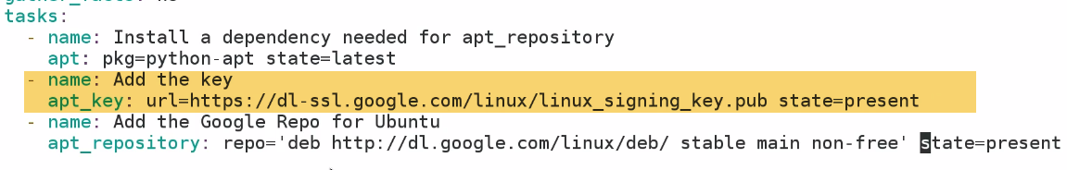

**-🡪' ACL' Module**

It sets and get, remove file access control list info.

It is needed that ACL enabled on target system.And setfacl, getfacl binaries are installed.

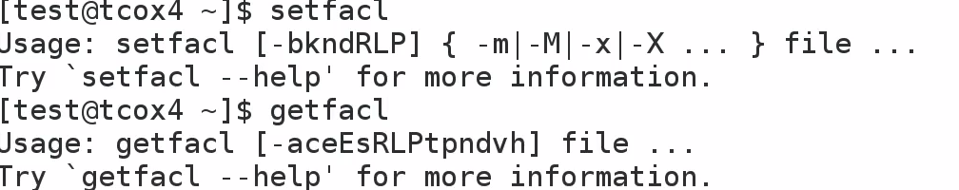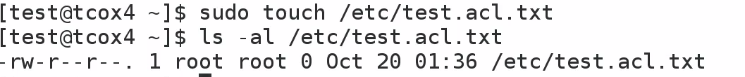

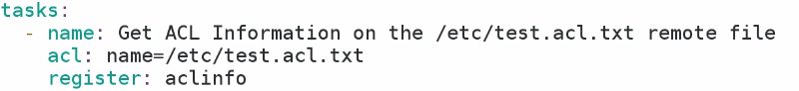

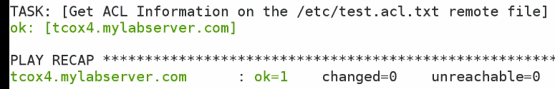

**No ACL info here..**

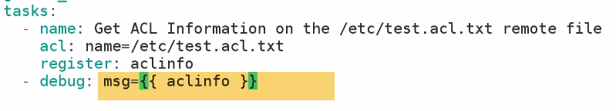

**Now we can get acl info. using debug module**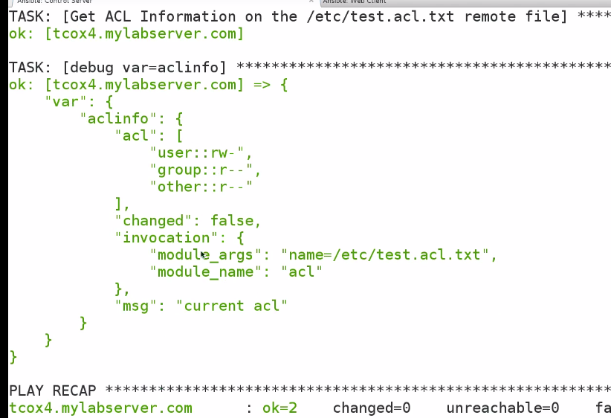

2.) 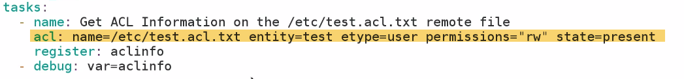





**We can see +1-🡪ACL been set for this particular user**

**To remove acl-🡪state=absent**

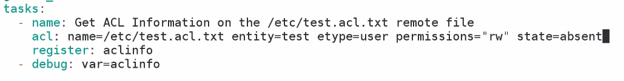

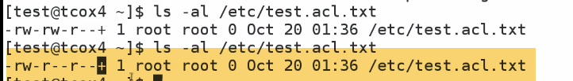

**File persmission have been reset**

**Bu ACL still present because we have set acl for that particular user to be absent.**

**Even after you reset, by rrmoving acl for particular user .U will still get ACL indicator when you list your FS.**

**-🡪GIT MODULE**

Interact with git-repo to build codes to other servers.**Core Modules for ansible configuration.**

- version

What version of the repository to check out. This can be the the literal string `HEAD', a branch name, a

tag name. It can also be a `SHA-1' hash, in which case `refspec' needs to be specified if the given revision

is not already available. [Default: HEAD]

- update

If `no', do not retrieve new revisions from the origin repository. (Choices: yes, no)[Default: yes]

- clone

If `no', do not clone the repository if it does not exist locally. (Choices: yes, no)[Default: yes]

**59-513-1 - Galaxy Introduction and Usage**

There are number of previously developed roles that can be used to use, or change as required. **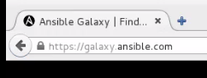****--empty**

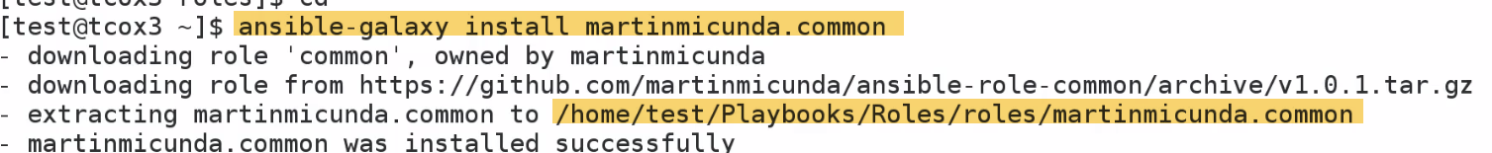

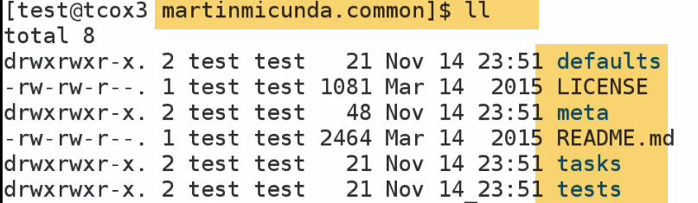

**59-519-1 - Ansible Command Line - Installing Packages**

Installing particular service across all servers..

If we have heterogeneous environments, we will have different packages for different environment.

Apache on Ubuntu-debian –>Apache2, Centos-yum ->httpd.

How can I divide that?

Ansible 2.0 and above there is package management system that will call appropriate apt or yum repos.

-u🡪user



**59-519-2 - Ansible Command Line - Services and Hosts**

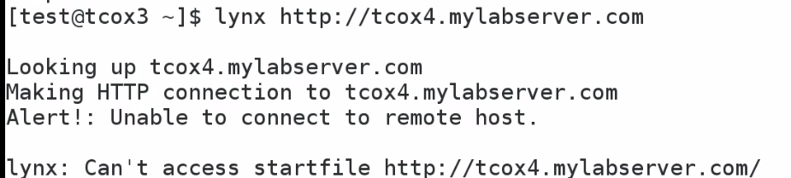

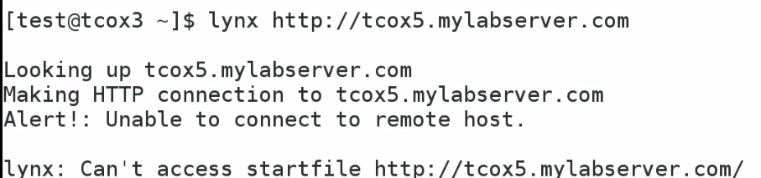

**-🡪59-519-7 - Ansible Command Line - Output Tree**

If we are managing large env.., we may have one control server that does one or one builds (mostly scheduled builds).We will get output back on JSON format depending on how to execute playbook.

We can take output and send to logfile..which will give us status of job for one or more jobs…

**Now. We will see…take directory as argument, and separate output by hosts**



**It will create directory install-results, also shows o/p on screen (like tee command)**

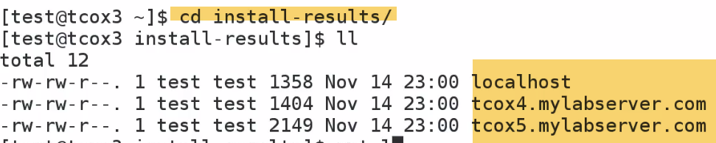



**NAMe Dircetory-🡪Date_time_scriptname_Pkginstalled.**

**This will give results by host**

**When I do auditing, json output into dB or format output on webpage will give results**

**-🡪59-519-4 - Ansible Command Line - Managing Users**

**Add account name –same all servers**



**We can also set gid and key-phrase**

**This will not delete files and folders created by user**



**Delete including user files**

**-**🡪**59-519-6 - Ansible Command Line - Running Arbitrary Commands**

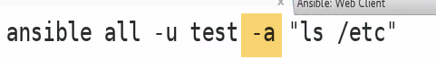

**Execute only command**

**59-519-5 - Ansible Command Line - Create and Manage Cron Jobs**

**AT: Run Only once –single min to 24 hrs from now**

**Cron: Run at midnight on day..**

* **Clean Log files..**
* **Restart webserver**



**Every week, every month, every year**

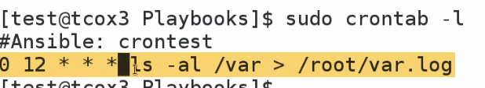





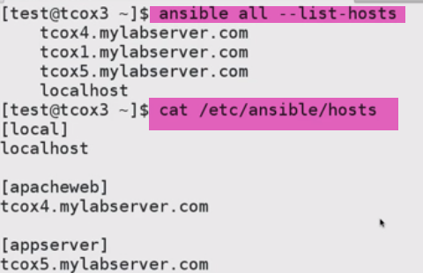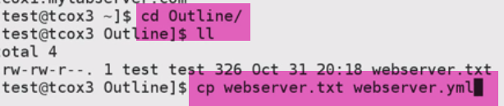-🡪rename to yaml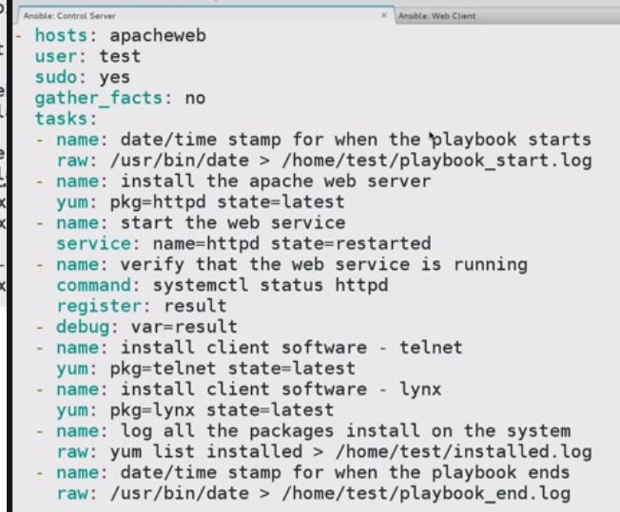

Check Syntax:



-🡪Running Playbook as a Dry RUN:

--check : connect to remote hosts. Look for what it will do on remote hosts using everyone of taks.., and what result might be..

Result: Wouldn’t be live..(Really wount be running commands)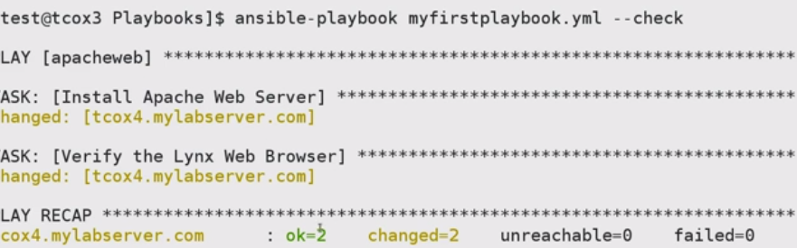

Change here=🡺 will be going to change if executed

OK=2, Change=2🡪 Install apache, lynx

Ok=2, Change=1🡪 IF apache installed, lynx to install

Ok=2, Change-1🡪 Lynx installed, Apache to install

Ok=2, Change=0🡪 both installed